

**Spring and Spring Boot**

Certainly! Let’s break it down:

1. **Spring**:
   * **What it is**: Spring is a Java framework for building applications. It provides us tools to build apps faster and more efficiently.
   * **Use Case**: Developers use Spring to create robust, modular, and maintainable Java applications. For example, it helps with connecting to databases, handling web requests, and managing security.
   * **Key Benefit**: Faster development due to reusable modules and infrastructure support.
2. **Spring Boot**: <https://www.geeksforgeeks.org/introduction-to-spring-boot/>
   * **What it is**: Spring Boot is built on the top of the spring and contains all the features of spring.. With Spring Boot, you get a lot of things done automatically. It’s like having a personal assistant for your app development used to create a Micro Service.
   * **Purpose**: It simplifies and accelerates Spring-based application development. The main goal of Spring Boot is to reduce development, unit test, and integration test time and in Spring Boot, there is no requirement for XML configuration.
   * **Use Case**: Spring Boot is ideal for creating **production-ready** applications quickly

**  
Goal**

* Let Spring handle routine task 🡪 Automation related routine tasks
* Manage the webdriver instance
* Manage Page Objects / fragments 🡪 @Autowiring
* Executing tests in multiple test environments like **dev/qa/stg/prod**
* Localization Testing for multiple languages
* Data driven testing by loading CSV file into a runtime DB
* Accessing files
* Automatic **window/frame** switching
* Taking Screenshots
* Parallel test execution
* Executing cucumber feature files with automatic dependency injection

**Pre-requisites & Assumptions**

|  |  |
| --- | --- |
| Sprint Boot | 0 Knowledge!!! |
| **Java** | Java 8 |
| Selenium | Basics |
| Cucumber | Not really needed |
| JUnit/TestNG | TestNG/JUnit |
| Maven | 3.3 and above versions |
| IntelliJ/Eclipse/IDE |  |

|  |  |
| --- | --- |
| **Spring Boot Topics** | **Description/Notes** |
| Spring Boot Basics | No test automation examples. Just basics of Spring Boot |
| Spring Boot with Selenium | Managing WebDriver, Automatic Dependency Injection of WebDriver, Page Objects, etc. |
| Spring bean scope | Executing tests in different Spring Boot environments |
| Aspect Oriented Programming | How to easily attach files using Spring Boot annotations |
| Accessing Files | Bean Scopes & Parallel tests with custom annotation |
| Spring Data JPA | Test-driven data testing, data management, Querying data, etc. |
| Logging | Logging into different files |
| Cucumber | Complete integration into a file |

**Source Code 🡪** [**https://github.com/vinsguru/spring-selenium**](https://github.com/vinsguru/spring-selenium)

**Let’s develop a simple microservice**

1. Go to <https://start.spring.io/>
2. Select Maven, Java
3. Select Packaging as Jar
4. Enter service name 🡪 math-service



1. Click on ADD DEPEDENCIES button
2. Choose Spring Web option



1. Click on GENERATE button
2. Open the project in IntelliJ
3. Create a .java file by name 🡪 MathController.java



10. Run the MathServiceApplication.java file



1. Check Spring logs



1. Open the browser
2. Hit the URL as <http://localhost:8080/add/2/6>



1. Change the code to get the output in JSON form



1. Create a new Response.java file



1. Re-run the MathServiceApplication.java file
2. Hit the URL as <http://localhost:8080/add/2/6>



**Spring Boot Basics**

**Dependency Injection**

* Object Dependency



Class

Class

Class



* Tight Coupling



* Loose Coupling



Anyone can use this. Just pass the driver instance and timeout property

In a nutshell, this is dependency injection

* Passing the dependencies

|  |  |
| --- | --- |
| With the constructor and setter approach, we assumed that someone else would create those objects. If you create them and provide them to me, I’ll start using them. I won’t create them myself. |  |

* Field Injection



Not passing dependencies via Constructor/Setter. See, this page object not only needs a webdriver instance, but also requires a few other web elements. However, to find them all, we need to pass a webdriver instance.

So what we really do here is once we get the webdriver, we use some kind of helper class pagefactory class to initialize the web elements.

How does the page factory class know what to initialize? 🡺 That is where the annotations come into picture. This page factory class scans the entire class and looks for the find by annotations using the driver instance and the find by annotation attributes. It initializes the page elements so we can interact with the page object.

This is a very convenient approach to model the page objects along with the other element attributes.

This PageFactory acts like mini spring microservice.

When we don’t pass dependencies via constructors or setters, we encounter a situation where a page object not only requires a WebDriver instance but also depends on several other web elements. To locate all these elements, we need to pass the WebDriver instance.

Here’s how it works: Once we obtain the WebDriver, we utilize a helper class called Page Factory. This class is responsible for initializing the web elements.

But how does the PageFactory class know what to initialize? That’s where annotations come into play. Essentially, the PageFactory class scans the entire class and identifies elements marked with the @FindBy annotation, using the driver instance and the attributes specified in the annotation.

By doing so, it initializes the page elements, allowing us to interact with the page object. This approach is incredibly convenient for modeling page objects along with their associated element attributes.

Remember it will work because of the PageFactory.initElements(). Otherwise, all the web elements would be null.

**Spring Initializer – Project Setup**

1. Go to <https://start.spring.io/>
2. Select Maven, Java
3. Select Packaging as Jar
4. Enter service name
5. Click on GENERATE button
6. Open the project in IntelliJ

Note: By-default Spring Boot comes with JUnit.

­­­­

**Dependency Injection without Spring Boot**

**Requirements**: In our system, we have 3 classes: User, Salary, and Address. The User class maintains references to both the Salary and Address objects. When we invoke the printDetails() method from the User class, it displays information about the salary and address.



|  |  |
| --- | --- |
|  |  |
|  |  |



Run the SpringSeleniumApplicationTests





We used to simulate business requirements like this.

[**Dependency Injection with Spring Boot**](https://medium.com/@anil.java.story/why-spring-constructor-injection-is-the-recommended-approach-75edca1f9b36)



User.java

Needs Address and Salary

**Requirements**: In our system, we have 3 classes: User, Salary, and Address. The User class maintains references to both the Salary and Address objects. When we invoke the printDetails() method from the User class, it displays information about the salary and address.

|  |  |
| --- | --- |
|  |  |

|  |  |
| --- | --- |
|  | **@Component 🡪**Hey Spring, take care of all the object creation. Used to indicate that a class is a candidate for auto-detection as a Spring bean/Object. Spring scans your application for classes annotated with @Component. It instantiates these classes and injects any specified dependencies into them.  **@Autowired** 🡪 Helps Spring - wire up your beans/objects automatically, making your code cleaner and more maintainable. It enables automatic dependency injection [Address/Salary]. Instead of manually configuring and creating objects, Spring automatically injects the necessary dependencies into your beans. We can use @Autowired in various ways: on properties, setters, and constructors. |
| Run the SpringSeleniumApplicationTests | |



|  |  |
| --- | --- |
| **@Autowired** | **@Component** |
| * For injecting dependencies into your Spring components (e.g., services, controllers, repositories). * When you want Spring to manage the wiring of beans automatically. | * For any class that should be treated as a Spring bean. * When creating custom components, utilities, or business logic. * It should be used for classes. |

[**Dependency Injection Using Setter Methods with Spring Boot**](https://medium.com/@anil.java.story/why-spring-constructor-injection-is-the-recommended-approach-75edca1f9b36)

**Requirements**: In our system, we have 3 classes: User, Salary, and Address. The User class maintains references to both the Salary and Address objects. When we invoke the printDetails() method from the User class, it displays information about the salary and address.



|  |  |
| --- | --- |
| Constructor | Constructor |

Run the SpringSeleniumApplicationTests



[**Dependency Injection Using Constructor with Spring Boot**](https://medium.com/@anil.java.story/why-spring-constructor-injection-is-the-recommended-approach-75edca1f9b36)

**Requirements**: In our system, we have 3 classes: User, Salary, and Address. The User class maintains references to both the Salary and Address objects. When we invoke the printDetails() method from the User class, it displays information about the salary and address.



|  |  |
| --- | --- |
| Constructor | Constructor |

Run the SpringSeleniumApplicationTests



[**Dependency Injection Using Field with Spring Boot**](https://medium.com/@anil.java.story/why-spring-constructor-injection-is-the-recommended-approach-75edca1f9b36)

**Requirements**: In our system, we have 3 classes: User, Salary, and Address. The User class maintains references to both the Salary and Address objects. When we invoke the printDetails() method from the User class, it displays information about the salary and address.





Run the SpringSeleniumApplicationTests



## **Key differences between @Autowired and Constructor Injection**

| **Feature** | **@Autowired** | **Constructor Injection** |
| --- | --- | --- |
| **Usage** | Can be applied to fields, methods, or constructors. | Applied only to the constructor. |
| **Annotation Location** | Applied directly to fields or methods. | Applied to the constructor. |
| **Dependencies Initialization** | Dependencies can be injected after the object is created (method injection). | Dependencies are injected during object creation. |
| **Preferred Approach** | Suitable for scenarios where flexibility in changing dependencies at runtime is needed. | Preferred approach for better code readability, testability, and immutability. |
| **Nullability** | Fields may be null if not initialized properly, leading to potential Null Pointer Exceptions. | Nullability is less of a concern, as dependencies are initialized during construction. |
| **Flexibility** | Offers flexibility in changing dependencies dynamically at runtime. | Promotes a more rigid structure, discouraging changes to dependencies after construction. |
| **Compile-time Safety** | May result in runtime errors if dependencies are not present or misconfigured. | Ensures compile-time safety as dependencies are resolved during compilation. |
| **Pros** | Offers flexibility for dynamic setups. | Emphasizes simplicity and clarity. |
| **Cons** | May scatter dependencies, potentially reducing readability. | Centralizes dependencies, making code more straightforward. |

**Dependency Injection - @Autowired**



Whenever we need an instance of a class, let’s do @Autowired and that class with @Component



Manage by Spring

**Dependency Injection – @Value**



* Value Injection with Default Values





without default_value

Run SpringSeleniumApplicationTests



*Another example*,



Run SpringSeleniumApplicationTests



|  |  |
| --- | --- |
|  | Spring says, if you define like @Value("${Path}") that means they are define somewhere in project may be in property file or may be under environment_variables or system variables of system/computer.  If you forgot to add those properties, then, will have errors/exceptions saying that, I cannot inject this value.  IllegalArguementException: Could not resolve placeholder ‘TEST_URL’ in value “${TEST_URL}”. |

We can also assign Default_Value if there is nothing mentioned anywhere to avoid exceptions.



If value is mentioned under let say property file then the default value will be replaced.

* Value Injection using Setter Methods





**// Field Injection**

**// Field Injection**

Run SpringSeleniumApplicationTests



***Setter Injection example*,**



Setter Injection Example

**// Field Injection**

Run SpringSeleniumApplicationTests



**Constructor/Setter/Field Injection**





No Setter methods, No Constructor. We depends on Spring Framework. It is mutable as there is no **private final field/constant**. So any member of the class can modify can mutate the instance variable.

**External Libraries - Dependency Injection**

Classes from external libraries

* @Bean
* @Configuration

**How to Autowire Objects from external libraries/3rd party libraries**

Let’s use <https://github.com/DiUS/java-faker> is a library (Java Faker is a fake data generator.) that can be used to generate a wide array of real-looking data from addresses to popular culture references.

Question: Why do we need it?

In order to perform software tests, we almost always need data to use in our test steps.

For example, you are testing “sign up with email” functionality.

You need email addresses to write in the email text box. You need valid and invalid email addresses for testing both negative and positive test scenarios.

Thanks to Java Faker, you can always populate a random valid email address to use in your tests.







These values are either environment variables or its coming from the property files, everything coming from environment variables, property files or the project’s classes. But Faker, it's coming from some external library and we would like to @Autowire it.

Let’s try this:



Caused by: org.springframework.beans.factory.UnsatisfiedDependencyException: Error creating bean with name 'address': Unsatisfied dependency expressed through field 'faker': **No qualifying bean of type 'com.github.javafaker.Faker' available**: expected at least 1 bean which qualifies as autowire candidate. Dependency annotations: [{@org.springframework.beans.factory.annotation.Autowired(required=true)}](mailto:%7b@org.springframework.beans.factory.annotation.Autowired(required=true)%7d)

Means it is not managed by Spring then how can I provide the data/values. Since Faker, it's completely coming from the 3rd party library so, how can I wire such objects which is coming from the 3rd party library?

**Let’s fix this problem**

Steps:

1. Go to our main application 🡪 src/main/java/spring_selenium/SpringSeleniumApplication.java



1. Click on annotation



1. Locate annotations



1. Create a package/folder by name “**config**”



We can move this package at some other level too but it will require additional configurations/settings/properties to configure.

1. Create a class under config package 🡪 FakerConfig.java



So,



When your Spring application starts up, it creates an “application context.” Think of this as a container that holds all the beans (objects) your application needs.

During this initialization, Spring scans your code for special annotations (like @Component, @Bean, @Configuration).

Spring sets up your Faker object so that it’s available for use throughout your application. It’s like putting the Faker in a shared container so everyone can easily find it!



Run SpringSeleniumApplicationTests





So,

* Bean is managed by spring
* @Bean is for 3rd party library at component is for your class.

**@Bean vs @Component**



1. **@Component**:

* It’s an **automatic configuraton**.
* Used for **component scanning** **and automatic wiring**.
* Annotate classes directly with `@Component`.
* Spring scans the classpath and automatically registers these classes as beans.
* Ideal for your own classes where you have access to the source code.

2. **@Bean**:

* It’s a **manual configuraton**.
* Used when automatic configuration is **not an option** (e.g., third-party libraries).
* Annotate a **method** within a `@Configuration` class.
* The method returns an object that Spring registers as a bean.
* You define the logic for creating the instance inside the method.
* Useful when you don't own the source code (e.g., external libraries).

In summary:

* Use `@Component` for simplicity and automatic scanning.
* Use `@Bean` when you need more control or when automatic configuration isn't feasible.







FakerConfig.java



So whenever we need to include a 3rd party object, we will be creating a separate class with **@Configuration** annotation and we can create methods which will be returning the object with the **@Bean** annotation.



Run SpringSeleniumApplicationTests



**Can I Autowire all?**

So whenever we need to include a 3rd party object, we will be creating a separate class with **@Configuration** annotation and we can create methods which will be returning the object with the **@Bean** annotation.

Recommendation is to avoid using **@Autowire**/**@Component** everywhere. Reason, it needs to be used only when Spring has to manage it. If there is an object at which we need more control let say in below example, we need to send a ‘welcome email’ to each of the 1000 users who purchase a product.



In such case, we cannot ask spring to inject email objects because we need more control here. Here, we are iterating the list of users and **creating new object/instance of Email every time with dynamic body content and dynamic subject line**. Here, we create Email instance, using it, destroying it (garbage collector will handle) after iteration ends.

***Bottom-line***: We are controlling Email object here, not controlled by spring. So, when we need Spring help to manage objects, we use annotations; else will go without annotations (just design the classes the way we usually do).

So whatever you think you need for the application to run, fine and it should not be changed for each and every test case. In that case, spring can manage it; else you have to manage it.

*Example*,

1. Create a java file 🡪 SendEmail.java



1. Create a class under config package 🡪 FakerConfig.java





Run



**Bean Lifecycle**

Certainly! Let’s break down the **bean life cycle** in simple terms using an example in the context of Java Spring:

1. **Bean Definition Acquisition**: The Spring container starts when your application runs. It reads bean definitions (usually from XML or annotations) and acquires information about the beans.
2. **Bean Creation and Instantiation**: The container creates an instance of a bean based on the bean definition. For instance, imagine a HelloWorld bean.
3. **Populating Bean Properties**: The container sets properties and values on the bean. Dependencies are injected into the bean. In our example, you might configure properties like a greeting message.
4. **Post-Initialization**: Custom initialization logic can be executed after property injection. You can define an init() method in your bean to perform any necessary setup. For instance, printing a message when the bean is instantiated.
5. **Ready to Serve**: The bean is now fully initialized and ready to be used by your application. In our case, the HelloWorld bean is ready to greet!
6. **Pre-Destroy**: When the Spring container is closed (e.g., during application shutdown), the beans are destroyed. You can define a destroy() method in your bean to handle cleanup tasks. [For example, logging a message when the container is closed](https://www.geeksforgeeks.org/bean-life-cycle-in-java-spring/).



 

In Spring applications, the IoC container is responsible for managing the life cycle of beans. The IoC container is the architectural backbone that handles the instantiation, configuration, and disposal of beans.



**Spring Bean Lifecycle Demo**

1. Create HelloWorld.java class



1. Create SpringSeleniumApplicationTests.java





**Inversion of control (IoC)**

Aim of Spring is to create loosely coupled applications. Instead of creating the dependencies ourselves, we ask spring to do it for us. So the IOC or Inversion of Control is a design principle which describes the inverting the flow of control in a system i.e., the execution flow is not controlled by your code. Instead, we gave this control to spring or spring took the control from us. This is why it's kind of called the inversion of Control.



Spring creates/configures beans, invoke method of beans and destroy the beans. So, basically automatic object creation method, invocation, lifecycle management, everything is happening with spring's assistance or spring is responsible for doing all these things.

No classes will be responsible of creating objects instead; Spring will provide all such objects/beans and destroy them.

In simple terms, **Inversion of Control (IoC)** in the Spring Framework means shifting the responsibility of creating and managing objects from your code to an external entity (the Spring IoC container). Instead of directly creating objects using the new keyword, you declare your dependencies, and the IoC container handles their creation and injection. This decouples classes, promotes better code organization, and enhances testability.

**IoC 🡪Instead of creating objects directly using constructors, you define their dependencies and let the container handle the wiring.**

**Summary:**

* Spring allows loose coupling by injecting the dependencies
* Spring boot is an extension for rapid development
* Constructor / Setter / Field injections
* Bean is a Java Object managed by Spring
  + @Component - for automatic configuration
  + @Configuration & @Bean for manual configuration
* @Autowired for spring beans
* @Value - from application.properties, environment variables etc
* Bean has a lifecycle
  + @PostConstruct 🡺 Something like @BeforeSuite()
  + @PreDestroy 🡺 Something like @AfterSuite()
* Spring is IoC container

**Assignment 🡪**

We would like to get a List<String> autowired with hard coded values like "a", "b", "c" in our test class. What should we do?

We’ll have to use **@Bean** as shown here.

@Bean

public List<String> list(){

return List.of("a", "b", "c");

}

**Spring Boot – Integration with Selenium**

WebDriver - Bean



* Bean
  + FirefoxDriver
  + ChromeDriver

To create a WebDriver, we need to use a **@Bean** annotation because it comes from a 3rd party library. Since it's not our class, we can't use `@Component`. We'll include dependencies like Webdriver Manager, Selenium, and TestNG dependencies. Then, we'll create a WebDriver configurations to define these beans. Finally, we'll create a page object and inject these dependencies to run our tests.

Let’s get started

Update pom.xml





1. Create WebDriverConfig.java under config folder like we created FakerConfig.java



In this, I have 2 Beans

* ChromeDriver
* WebDriverWait

1. Create BaseClass (may be an abstract class) under a new package 🡪 page



1. Create an abstract base class 🡪 Base.java



1. Create SearchBus component class under src/main/java/ com.udemy.spring.spring_selenium.page.**redbus**

@Component

public class SearchBus extends Base {

@FindBy(css = "#src.sc-bxivhb")

public WebElement from;

@FindBy(css = "#dest.sc-bxivhb")

public WebElement to;

@FindBy(className = "labelCalendarContainer")

public WebElement date_picker;

@FindBy(xpath = ".//div[starts-with(@class,'DatePicker__MainBlock')]" +

"//div[starts-with(@class,'DayTilesWrapper__RowWrap')]" +

"//span//div[starts-with(@class,'DayTiles__CalendarDaysBlock')]" +

"/span[starts-with(@class,'DayTiles__CalendarDaysSpan')]")

public List<WebElement> days;

@FindBy(id = "search_button")

public WebElement searchButton;

@Override

public boolean isAt() {

JavascriptExecutor js = (JavascriptExecutor) driver;

return this.webDriverWait.until((driver) -> js.executeScript("return document.readyState").equals("complete"));

}

public void searchBusForToday(String from, String to) {

this.from.sendKeys(from);

this.from.sendKeys(Keys.ENTER);

this.to.sendKeys(to);

this.to.sendKeys(Keys.ENTER);

this.date_picker.click();

this.selectCurrentDay();

}

public void clickSearchBusesButton() {

this.searchButton.click();

}

private void selectCurrentDay() {

this.days

.stream()

.filter(webElement -> webElement.isEnabled()

&& webElement.isDisplayed()

&& webElement.getCssValue("background").contains("rgb(239, 67, 72)")

)

.findFirst()

.ifPresent(WebElement::click);

}

}

1. Create SearchResults class under src/main/java/ com.udemy.spring.spring_selenium.page.**redbus**



1. Create Main Page class under src/main/java/ com.udemy.spring.spring_selenium.page.**redbus** 🡪 RedBusPage.java
2. Create SpringBaseTestNGTests.java similar to SpringSeleniumApplicationTests.java under src/test/java/com.udemy.spring.spring_selenium.SpringBaseTestNGTests to work with TestNG



1. Create a folder ‘redbusTest’ under src/test/java/com.udemy.spring.spring_selenium.SpringBaseTestNGTests
2. Create a class 🡪 RedBusTest.java



**Run the test**

**ScreenShotUtil - Spring Component**

Steps:

1. Create a package



1. Create ScreenshotUtil.java class



1. Set the path under application.properties file 🡪 screenshot.path



1. @Autowire the ScreenshotUtil at test level and run the test



**NOTE:**

Now, if you examine ScreenshotUtil, we didn’t explicitly define TakesScreenshot as @Bean. Then how did it work. Ideally, we should have successfully created this bean somewhere? 🡪

But, how did Spring manage to work?

The reason is Spring can automatically inject it is because it does something clever. When you look at the ChromeDriver, it’s implementing the RemoteWebDriver. Now, if you go inside this RemoteWebDriver, it’s essentially implementing the TakesScreenshot interface indirectly. In other words, the ChromeDriver can be converted into a TakesScreenshot type.

So what does Spring do? It checks the object type. It thinks, “Ah, I have a ChromeDriver. Maybe that’s what you need.” It then automatically converts it to the required type and provides it to you. That’s what we’re accomplishing ScreenshotUtil.

Normally, we’d manually convert the WebDriver to the TakesScreenshot type and invoke the method. But Spring handles all of this behind the scenes. So when you say this.driver.getScreenshot(), Spring allowing you to directly invoke the method.

In summary, Spring takes care of these conversions seamlessly!

In the context of Spring Boot and Chrome WebDriver, let's discuss why `TakesScreenshot` and `JavascriptExecutor` interfaces are not directly related to creating beans.

1. **TakesScreenshot** Interface:

* The TakesScreenshot interface is part of Selenium WebDriver, not Spring Boot.
* It allows you to capture screenshots of the current browser window or a specific element.
* However, creating Spring beans (components managed by the Spring container) doesn't inherently involve taking screenshots.
* If you need to capture screenshots during test execution, you can use TakesScreenshot in your test classes, but it's not directly related to Spring bean creation.

2. **JavascriptExecutor** Interface:

* The JavascriptExecutor interface also belongs to Selenium WebDriver.
* It allows you to execute JavaScript code within the context of the browser.
* While it's a powerful tool for interacting with web pages (e.g., scrolling, modifying DOM elements), it's not directly tied to Spring bean configuration.
* Spring beans are typically defined in configuration classes (annotated with @Configuration) or through component scanning (e.g., @ComponentScan).
* The JavascriptExecutor is useful for enhancing your test automation but doesn't impact Spring bean creation.

In summary, Spring Boot and Selenium WebDriver serve different purposes: Spring Boot manages application components (including beans), while Selenium WebDriver interacts with web browsers. Although both are essential for different aspects of application development, they don't directly overlap in terms of functionality.

**Lazy Bean**

* Beans can be lazy!
* @Lazy should be used along with @Component/@Bean & @Autowired

In Spring Boot, the @Lazy annotation is used to mark a bean or component as **lazy-initialized**. This means that the bean won’t be instantiated until its first requested by another bean or by the use.

1. Using @Lazy with @Configuration Class: When you put the @Lazy annotation over a @Configuration class, it indicates that all methods with @Bean annotations should be loaded lazily.
2. Using @Lazy with @Autowired: To initialize a lazy bean, reference it from another bean.



In above example, let say here it launched the browser and it did not do anything instead was waiting for this component to be ready. Once it's ready, then the test will run.

And there is no screenshot here because we are not taking any screenshot that we removed that method. And also I'm injecting the component ScreeshotUtil but I'm not doing anything. So this is a kind of a **problem** and this could happen?

Because what happens here is when spring actually starts, it will try to create all the beans for you. Meaning, all the Webdriver, WebDriverWait, RedBusPage component, SearchBus component, SearchResults component, ScreeshotUtil component. It will create all the objects, all the beans, and it will have everything ready and whoever asks for it, it will just give it.

And similarly it will also create the ScreeshotUtil because it's a spring component. So spring will create it. So as part of the creation process, it will also be executing that post construct method @PostConstruct.

But, the @PostConstruct method can be time consuming method. Maybe you are doing some database operation, maybe you are doing something very time consuming operation. Because of that, it takes so much time and so because of that, it takes some time.

But since all objects are created y Spring and the point here is you are not using it. Sounds weird! Regarding the end of the day, I am not using those methods/I am not using those components at all/I am not taking the screenshot. I am not using it. If I'm going to use this, maybe it makes sense. If I'm not going to use it, why do we have to do all this heavy operation?

So this is a **problem**. So Spring solves the problem.

Hey Bean! You are going to be a lazy bean **@Lazy**. Remember that the lazy comes from spring framework. You are telling Spring that just do it Lazy.



So what it means is that if somebody really wants you and when you create it, yeah, do all these things, do not do anything proactively.

Hey Spring, I am just doing it. But I might not be using it anywhere. If I'm going to use it, that time you create all those objects, otherwise don't do it.





Let's rerun the test. 🡪



Let's see what happens.



So, if you think that certain objects you want them to be created only when the time comes and you want spring to create, you can use @Lazy. So, the spring beans can be lazy.

So what should I do for being so for the beans (Manual configuration using @Configuration)?

You can do @Lazy here too either at specific bean or at entire class level.

Remember that whenever you mention @Lazy, you have to keep this in the @Configuration class and the @Component class. And when you @Autowire it, even in this place, you have to mention that lazy.

**Unique Bean**

Spring should be able to inject beans uniquely!!!

● @Primary

● Conditions

○ @ConditionalOnProperty

○ @ConditionalOnExpression

○ @ConditionalOnMissingBean

● @Qualifier



And, run the test



We have added the ChromeDriver and FirefoxDriver, but our spring boot framework got confused. What to inject when somebody asks for Webdriver instance, because it sees 2 webdriver Beans, so it does not know which one to provide.

**Injecting Unique Bean -- @Primary**

So whenever there is confusion where there could be multiple implementations for a same type, the fix can be done by adding @Primary annotation.

If you have multiple beans of the same type (e.g., Car and Bike for the Vehicle type), you can use @Primary to give higher preference to a specific bean. Mark one of the beans with @Primary to resolve the conflict.



And, run the existing test 🡪

**Injecting Unique Bean -- @ConditionalOnProperty**

The @ConditionalOnProperty annotation in Spring allows you to conditionally create beans based on the presence and value of a configuration property. Here’s how it works:

Purpose of @ConditionalOnProperty:

* When developing Spring-based applications, you might need to create beans conditionally based on configuration properties (.properties files).
* For example, you may want to register a DataSource bean pointing to a production or test database depending on a property value (e.g., “prod” or “test”).
* The @ConditionalOnProperty annotation enables bean registration only if an environment property is present and has a specific value.
* By default, the specified property must be defined and not equal to false.





We can run the tests via commandLine as well 🡪

mvn clean test –Dbrowser=firefox

At times, running ”**mvn clean test**” doesn’t behave as expected—it defaults to using the JUnit runner for our tests. However, since our tests are written with TestNG annotations, we’re looking for a solution to make the Surefire plugin use the TestNG runner instead of JUnit. Refer <https://maven.apache.org/surefire/maven-surefire-plugin/examples/testng.html>.

**Injecting Unique Bean -- @ConditionalOnMissingBean**

Purpose:

* The @ConditionalOnMissingBean annotation is used to conditionally create a bean only if a specific bean of the same type is not already present in the application context.
* In other words, it acts as a fallback mechanism or a default option when a particular bean is missing.

Example Scenarios:

* Fallback Bean:
  + Imagine you have a database configuration bean, but you want to provide an in-memory database as a fallback option.
  + You can use @ConditionalOnMissingBean to create the in-memory database bean only if no real database bean is configured.
* Default Bean Override:
  + Suppose you have a default authentication mechanism bean.
  + If someone wants to replace it with a custom authentication bean, they can do so.
  + The default bean will be created only if no specific authentication bean is present.
* Usage:
  + Annotate a method or configuration class with @Bean and @ConditionalOnMissingBean.
  + If no bean of the specified type exists in the context, the annotated bean will be created and registered.

Note -- @ConditionalOnMissingBean annotation should be at last.

So in below example, if value = firefox then create firefox bean else will create chrome bean as it is annotated with @ConditionalOnMissingBean.



**Injecting Unique Bean -- @ConditionalOnExpression**

Purpose:

* The @ConditionalOnExpression annotation allows you to conditionally include or exclude configuration based on the result of a Spring Expression Language (SpEL) expression.
* In other words, it lets you control whether a component or bean is created based on a specific condition expressed using SpEL.

Example Scenarios:

* Custom Modules:
  + Suppose you have different modules in your application, and you want to load a specific module only if a certain condition is met.
  + You can use @ConditionalOnExpression to evaluate an expression and decide whether to include that module.
* Fine-Grained Configuration:
  + Imagine you want to create a bean only when multiple conditions are satisfied (e.g., specific property values, environment settings, or other factors).
  + @ConditionalOnExpression allows you to express complex conditions using SpEL.

Usage:

* Annotate a class (e.g., @Configuration, @Component, @Service, or @Repository) or a method (annotated with @Bean) with @ConditionalOnExpression.
* Provide the SpEL expression as a string parameter to the annotation.
* Spring evaluates the expression during context initialization and determines whether to create the associated bean or configuration.



**Example Steps:**

1. Create a class LoggerConfig.java
2. Create class LoggingService.java
3. Add property in application.properties file
4. Add Logger in GoogleTest.java
5. Run the test











And, run the test 🡪

**Question**: If any class is annotated with @ConditionalOnExpression then do we need to annotate the same class with @Component annotations of spring boot.

**Answer**: When using @ConditionalOnExpression in Spring Boot, you don't necessarily need to annotate the same class with @Component. Let's break it down:

1. **@**ConditionalOnExpression**\*\*:

* This annotation allows you to conditionally create a bean based on an expression.
* It checks whether the specified expression evaluates to **true** before creating the bean.
* You can use it to control bean creation based on properties, environment variables, or other conditions.

2. **@**Component**\*\*:

* The @Component annotation is part of Spring's component scanning mechanism.
* It marks a class as a Spring bean, allowing it to be automatically discovered and registered in the application context.
* It's commonly used for classes that provide business logic, services, or other components.

3. **Usage**:

* You can use @**ConditionalOnExpression** without @**Component** if your class doesn't need to be automatically discovered as a Spring bean (i.e., you don’t need dependency injection).
* If your class serves as a bean and requires automatic registration, you can use both annotations together.

4. **Example**:

MyConfig.java

```

@Configuration

@ConditionalOnExpression("${my.property:true}")

public class MyConfig {

// Configuration logic here

}

```

* In this example, `MyConfig` will be created as a bean only if the expression `${my.property:true}` evaluates to `true`.

Remember that the decision to use `@Component` depends on whether you want Spring to manage the lifecycle of your class as a bean. If you don't need automatic discovery, you can skip the `@Component` annotation. Otherwise, use both annotations as needed.

**Injecting Unique Bean -- @Qualifier**

The @Autowired annotation is a great way of making the need to inject a dependency in Spring explicit. Although it’s useful, there are use cases for which this annotation alone isn’t enough for Spring to understand which bean to inject.

By default, Spring resolves autowired entries by type.

**If more than one bean of the same type is available in the container, the framework will throw NoUniqueBeanDefinitionException**, indicating that more than one bean is available for autowiring.

By using the **@Qualifier** annotation, **we can eliminate the issue of which bean needs to be injected.**

Example:









Run the CarTest tests. This will log output as “**BMW**”

**WebDriver - Managed By Spring**



Here, I want to execute all **100 test cases** as part of one **single test run** within a **single Jenkins job**. And, during this run, I need to run all **100 test cases** in either **Chrome/Firefox**. Then here, Chrome WebDriver **will be** **managed by Spring.**

Certainly! It seems you have a specific requirement for executing your test cases. Let's break it down:

1. You want to execute all **100 test cases** as part of one **single test run** within a **single Jenkins job**.

2. During this run, you need to run one test in **Chrome** and another test in **Firefox**.

3. These two tests should run **in parallel** using separate threads.

4. Then here, Chrome WebDriver is **not managed by Spring**, and you want more control over it.

Is that a correct understanding of your requirement? If so, you're right that managing the WebDriver directly gives you greater flexibility. Let's explore how to achieve this!

**WebDriver - Managed By You**





It seems you have a specific requirement for executing your test cases. Let's break it down:

1. You want to execute all **100 test cases** as part of one **single test run** within a **single Jenkins job**.

2. During this run, you need to run one test in **Chrome** and another test in **Firefox**.

3. These two tests should run **in parallel** using separate threads.

4. Then here, Chrome WebDriver is **not managed by Spring**, and you want more control over it.

**Profile – Properties**







**GoogleTest.java**



Configure profile



**Apply and OK**

**Run the GoogleTest 🡪 Test Passed**

**At Windows, Run the GoogleTest at terminal 🡪**

1. Update pom.xml





1. Open terminal and run 🡪 **mvn clean test**
2. **Test Passed**
3. Open terminal and run 🡪

**mvn clean test -Dbrowser=firefox "-Dspring.profiles.active=stg"**

**Running Selenium Grid**

Use **docker** for selenium grid. This is the easiest way!

* Install docker
* Create a file called - docker-compose.yaml
* Copy the content from my Github project [here](https://github.com/vinsguru/selenium-docker/blob/master/04-selenium-grid/01-simple-grid/docker-compose.yaml) and paste.
* Issue docker-compose up command to bring up selenium grid & docker-compose down for bringing it down.
* You should be able to access the grid http://localhost:4444
* Please do note that WebDriver will be using http://localhost:4444/wd/hub as the grid URL.

**Steps:**

* Create a RemoteWebDriverConfig.java

@Lazy  
@Configuration  
public class RemoteWebDriverConfig {  
 @Value("${selenium.grid.url}")  
 private URL url;  
 @Value("${default.timeout:30}")  
 private int timeout;  
  
 @Bean  
 @ConditionalOnProperty(name = "browser", havingValue = "firefox")  
 public WebDriver remoteFirefoxDriver() {  
 return new RemoteWebDriver(this.url, new FirefoxOptions());  
 }  
  
 @Bean  
 @ConditionalOnMissingBean  
 public WebDriver remoteChromeDriver() {  
 return new RemoteWebDriver(this.url, new ChromeOptions());  
 }  
  
 @Bean  
 public WebDriverWait webDriverWait(WebDriver driver) {  
 return new WebDriverWait(driver, Duration.*ofSeconds*(this.timeout));  
 }  
}

* Create application-remote.properties

selenium.grid.url=http://localhost:4444/wd/hub

* Create docker-compose.yaml file
* Copy the content from <https://github.com/tlakshakar/docker-journey/blob/master/workspace/04-selenium-grid/03-max-session/docker-compose.yaml>
* Make sure that Docker Desktop application is UP and running
* Open command prompt
* Go to location where docker-compose.yaml present
* Type “docker-compose up -d“ at command prompt
* Hit the URL to ensure selenium grid is UP 🡪 <http://localhost:4444/ui/>



* Add an annotation @Profile to RemoteWebDriverConfig.java and WebDriverConfig.java

The situation is we have a total of 4 beans (2 from RemoteWebDriverConfig and 2 from WebDriverConfig).

Beans =

* remoteFirefox
* remoteChrome
* localFirefox
* localChrome

We are using @ConditionalOnProperty (name = "browser", havingValue = "firefox"). As a result, only 1 bean related to Firefox will be active (either from RemoteWebDriverConfig or from WebDriverConfig).

However challenge is both RemoteWebDriverConfig and WebDriverConfig classes define the same properties. This lack uniqueness and can confuse Spring.

To keep Spring Boot happy, we can use **@Profile** annotation which means is that

* If someone passes a ‘remote’ profile, we activate the RemoteWebDriverConfig configuration.
* If we don’t specify anything in the WebDriverConfig class, it will be activated for all profiles.
* To ensure that RemoteWebDriverConfig is only activated for the remote profile, we annotate it with **@Profile("remote")**. Conversely, we mark WebDriverConfig with **@Profile("!remote")** to prevent activation for the ‘remote’ profile.

This way, we maintain clarity and avoid confusion in our Spring Boot configuration.

* Edit the IntelliJ configurations 🡪 spring.profiles.active=remote,stg



* Click Apply and OK buttons
* Run the GoogleTest via command line 🡪 mvn clean test –Dbrowser=firefox “-Dspring.profiles.active=remote,stg”





To run the GoogleTest using IntelliJ configurations, make sure under pom.xml, you disabled <spring.profiles.active> property as mentioned below  
 

Now, Run the GoogleTest

**TEST PASSED**



If I want to run test locally (not on selenium grid [remotely]) then mvn clean test –Dbrowser=firefox “-Dspring.profiles.active=stg”



**Profile - @Component/@Bean**



Refactor the code as WebdriverWait is simply copy-paste in both RemoteWebDriverConfig and WebDriverConfig classes. Let’s create a separate class WebDriverWaitConfig

@Lazy  
@Configuration  
public class WebDriverWaitConfig {  
 @Value("${default.timeout:30}")  
 private int timeout;  
  
 @Bean  
 public WebDriverWait webdriverWait(WebDriver driver){  
 return new WebDriverWait(driver, Duration.*ofSeconds*(this.timeout));  
 }  
}

**Summary**

* Spring allows loose coupling by injecting the dependencies
* Spring boot is an extension for rapid development
* Constructor / Setter / Field injections
* **Bean** is a Java Object managed by Spring
  + **@Component** - for automatic configuration
  + **@Configuration & @Bean** for manual configuration
* **@Autowired** for spring beans
* **@Value** - from application.properties, environment variables etc
* Bean has a lifecycle
  + @PostConstruct
  + @PreDestroy
* Spring is IoC container
* Profiles can be used for environment specific details
  + URL
  + Username/Passwords
* Profiles can be combined
  + remote+qa
  + local+stg
* spring.profiles.active=qa,remote
* Bean can be @Lazy
  + Do not forget to add @Lazy in all places @Autowired & @Bean/@Component

**Note** 🡪 @Lazy is not related to inject a bean uniquely.

**Spring Boot – Integration with Selenium**

**Bean Scope**

In the Spring framework, **bean scopes** define the lifecycle and visibility of a bean within the application context.

* **Singleton**: This is the default scope. A single instance of the bean is created and shared across the entire Spring container. All requests for that bean return the same instance.

@Component

public class MySingletonBean {

// Bean definition

}

* **Prototype**: A new instance of the bean is created every time it is requested from the container.

@Component

@Scope("prototype")

public class MyPrototypeBean {

// Bean definition

}

* **Request**: A new instance of the bean is created for each HTTP request. This scope is only valid in a web-aware Spring application context.

@Component

@Scope(value = WebApplicationContext.SCOPE_REQUEST, proxyMode = ScopedProxyMode.TARGET_CLASS)

public class MyRequestBean {

// Bean definition

}

* **Session**: A new instance of the bean is created for each HTTP session. This scope is also only valid in a web-aware Spring application context.

@Component

@Scope(value = WebApplicationContext.SCOPE_SESSION, proxyMode = ScopedProxyMode.TARGET_CLASS)

public class MySessionBean {

// Bean definition

}

* **Application**: A single instance of the bean is created for the lifecycle of a ServletContext. This scope is valid in a web-aware Spring application context.

@Component

@Scope(value = WebApplicationContext.SCOPE_APPLICATION)

public class MyApplicationBean {

// Bean definition

}

* **WebSocket**: A new instance of the bean is created for the lifecycle of a WebSocket. This scope is valid in a web-aware Spring application context.

@Component

@Scope(value = "websocket", proxyMode = ScopedProxyMode.TARGET_CLASS)

public class MyWebSocketBean {

// Bean definition

}

To understand this, let’s create an example where as a user, I would like to set salary of Junior/Senior Engineer and printing salary of each engineer to see at console.

Steps:

* 1. Create a package ‘scope’
  2. Create a class annotated with @Component 🡪 Salary

@Component  
public class **Salary** {  
 private int amount;  
  
 public int getAmount() {  
 return amount;  
 }  
  
 public void setAmount(int amount) {  
 this.amount = amount;  
 }  
}

* 1. Create 2 classes annotated with @Component 🡪 JuniorEng/SeniorEng

@Component  
public class **JuniorEng** {  
 @Autowired  
 private Salary salary;  
 public Salary getSalary() { return salary; }  
 public void setAmount(int amount){ this.salary.setAmount(amount); }  
}

@Component  
public class **SeniorEng** {  
 @Autowired  
 private Salary salary;  
  
 public Salary getSalary() {  
 return salary;  
 }  
  
 public void setAmount(int amount){  
 this.salary.setAmount(amount);  
 }  
}

* 1. Create a TestNG Test 🡺 JuniorSeniorTest

public class JuniorSeniorTest extends SpringBaseTestNGTests {  
 @Autowired  
 private JuniorEng junior;  
 @Autowired  
 private SeniorEng senior;  
  
 @Test  
 public void scopeTest(){  
 this.junior.setAmount(100);  
 System.*out*.println("Junior :: " + this.junior.getSalary().getAmount());

this.senior.setAmount(200);  
 System.*out*.println("Senior :: " + this.senior.getSalary().getAmount());

System.*out*.println("Junior :: " + this.junior.getSalary().getAmount());  
 }  
}

* 1. Run the test
  2. Observe output



**PROBLEM 🡪why salary of Junior is changed to 200$**

**Reason**: Whenever Spring Boot creates a bean, it always assumes that in scope, which is by default, it's a singleton scope.

**What is Singleton**? 🡪 Singleton is only one instance of the bean will be created for the entire lifetime of the application. If you are planning to run 1000 test cases in one single run, only one webdriver will be created, only one instance of the bean will be created. In this case, for the junior-senior, only one instance of the salary was created and that was shared with all the objects. Whenever somebody asks like, *hey! can you give me the salary bean.* Spring Boot will be giving the same salary bean to everybody. So junior, senior manager, director, CTO, CEO, etc., everybody will be getting the same salary. So, when you try to run 2 tests, here, only one instance of the browser was created due to Singleton scope and shared with the threads.

**Singleton Scope**

* Only one instance of the Bean -- @Component
* Shared with all the objects
* Shared with all the threads
* Good for Reporting / Logging
* Avoid mutating instance variables
* Your responsibility to keep it thread safe!



**Prototype Scope**

* Fresh instance for all!
* Note: **@PreDestroy** is not invoked!!

To fix the problem, let’s annotate with @Scope

@Component  
@Scope("prototype")  
public class Salary {  
 private int amount;  
  
 public int getAmount() {  
 return amount;  
 }  
  
 public void setAmount(int amount) {  
 this.amount = amount;  
 }  
}

Run the test again





Now, as you know, since **@Component** by default, it will be a singleton scope. So only one Google page instance will be created and all the threads will be using the same instance which we do not want.

**Need to add these many annotations at each page object like GooglePage, RedBusPage, SearchResultComponent, SearchComponent, SearchResults, SearchBus etc., meaning, for all the beans we have created, they all should have these many annotations.**



Yes, in Spring Boot, when you annotate a class with **@Component**, it is by default a **singleton**. This means that Spring will create only one instance of the bean, and this instance will be shared across the entire application context.

If you need a different scope, you can use the @Scope annotation to specify it. For example, to create a new instance every time the bean is requested, you can use @Scope("prototype").

Let’s create **Custom Annotations**



* Create annotation class 🡪 **PageAnnotations.java**

@Lazy  
@Component  
@Scope("prototype")  
@Documented   
@Target({ElementType.*TYPE*})  
@Retention(RetentionPolicy.*RUNTIME*  
public @interface PageAnnotations {  
 String value() default "Can annotate a class";  
}

* Create annotation class 🡪 **PageFragment.java**

@Lazy  
@Component  
@Scope("prototype")  
@Documented  
@Target({ElementType.*TYPE*})  
@Retention(RetentionPolicy.*RUNTIME*)   
public @interface PageFragment {  
 String value() default "Can annotate a class";  
}

Now since we created custom_annotations, let’s remove **@Lazy, @Component, @Scope("prototype")** across each page objects **(GooglePage, RedBusPage)** and its components **(SearchResultComponent, SearchComponent, SearchResults, SearchBus)** and add **@PageAnnotations** and **@PageFragment.**

//@Lazy  
//@Component  
//@Scope("prototype")  
@PageAnnotations  
public class GooglePage extends Base {}

@PageFragment  
public class SearchComponent extends Base {}

@PageFragment  
public class SearchResultComponent extends Base {}

//@Lazy  
//@Component  
//@Scope("prototype")  
@PageAnnotations  
public class RedBusPage extends Base {}

//@Component  
@PageFragment  
public class SearchBus extends Base {}

//@Component  
@PageFragment  
public class SearchResults extends Base {}

* Create annotation class -> **LazyConfiguration.java**

@Lazy  
@Configuration  
@Documented  
@Target({ElementType.*TYPE*})  
@Retention(RetentionPolicy.*RUNTIME*)   
public @interface LazyConfiguration {  
 String value() default "Can annotate a class";  
}

Now since we created custom_annotations of LazyConfiguration, let’s remove **@Lazy, @Configuration** across FakerConfig.java, WebDriverWaitConfig.java, WebDriverConfig.java, RemoteWebDriverConfig.java, LoggerConfig.java and add @LazyConfiguration.

@Profile("!remote") // NOT condition  
@LazyConfiguration  
public class WebDriverConfig {

@LazyConfiguration  
public class WebDriverWaitConfig {

@LazyConfiguration  
@Profile("remote")  
public class RemoteWebDriverConfig {

@LazyConfiguration  
public class LoggerConfig {

@LazyConfiguration  
public class FakerConfig {

We have annotated almost all classes with custom_annotations but chromeDriver/firefoxDriver is still singleton. Let’s annotate them with @Scope(“prototype”) annotation.

@Bean  
@Scope("prototype") // The @Scope("prototype") annotation ensures that each time the chromeDriver bean is requested, a new instance of ChromeDriver will be created.  
@ConditionalOnMissingBean  
public WebDriver chromeDriver() {  
 WebDriverManager.*chromedriver*().setup();  
 return new ChromeDriver();  
}

But here is a problem, if we try to add @Scope annotation at WebDriver instance creation level to provide a new WebDriver instance for each test then it launches multiple browsers more than 5-6 and nothing happens kind of stuck.

**WebDriver – Prototype 🡪 Create object every time!**



Each and every instance, page objects, page components (SearchComponent, ResultComponent, etc.,), they all have its own Webdriver instance. The thread-1 (GooglePage) thread-2 (RedBusPage) - they are creating Webdriver instance, but within the thread each page object is creating its own Webdriver instance, that's not good because see, as part of a thread, you will be executing a test case which involves multiple page objects. 🡪 launches multiple browsers more than 5-6

Basically, you will be testing a workflow 🡪logging in as a consumer, going to a different screen for searching the product. Then you go to a different screen of selecting the product, entering the payment information. Then you go to the last page object of verifying the order, information, this kind of stuff, order a product, order confirmation.

So as part of a business workflow, multiple page objects are involved -- page objects, page component etc. If each and every page object is going to launch its own webdriver instance, then we cannot complete the workflow.

Each instance, page object, and page component has its own WebDriver instance. Threads like thread-1 and thread-2 create WebDriver instances, but within each thread, every page object also creates its own WebDriver instance. This is problematic because, within a thread, you execute a test case involving multiple page objects.

Typically, you test a workflow such as logging in as a consumer, navigating to a different screen to search for a product, selecting the product, entering payment information, and finally verifying the order and order confirmation. This business workflow involves multiple page objects.

If each page object launches its own WebDriver instance, completing the workflow becomes impossible.

The idea is WebDriver thread should be shared across all the page objects so that we can continue with the workflow.

*So,* ***Singleton*** *and* ***@Scope(“prototype”)*** *both doesn’t seem to work.*

**Singleton** 🡪 Create only one object

**@Scope(“prototype”)** 🡪 Create object every time

We need some other @Scope 😐

**WebDriver – Thread Scope!**



**It is not documented properly** in spring-boot but what it will do is that if thread-1 creates an object, then the same object will be given to all the spring-boot components. Whenever you @Autowire it same, the component will be given to everybody. So because of that, what will happen is if there are multiple page objects, they all will be sharing the same Webdriver instance.



Once the **driver.quit()** is called then thread scope will be destroyed and nothing will work.

So problem won’t fix here ☹

Let’s create **Custom ThreadScope**

|  |  |  |
| --- | --- | --- |
| **Singleton** | **Scope(“prototype”)** | **Thread Scope** |
| Singleton is only one instance of the bean will be created for the entire lifetime of the application. If you are planning to run 1000 test cases in one single run then only 1-webdriver instance will be created, only one instance of the bean will be created. In case of junior-senior example, only one instance of the Salary was created and that was shared with all the objects. | Create a new instance every time the bean is requested. Each page object and page component has its own WebDriver instance. Threads like thread-1 and thread-2 create WebDriver instances, but within each thread, every page object also creates its own WebDriver instance. This is problematic because, within a thread, you execute a test case involving multiple page objects. | If thread-1 creates an object, then the same object will be given to all the spring-boot components. Whenever you @Autowire it same, the component will be given to everybody. But if we do driver.quit() then scope of thread will be destroyed and nothing will work after that. |

**Custom ThreadScope**



The idea is to use thread-local storage internally. Thread-local storage is essentially a map associated with the thread name or thread ID.

When a thread requests a browser instance, we check if the browser is active and hasn’t been quit. If it’s still active, we return the existing browser instance. If the browser has been quit, we remove it from the map, create a new browser instance, add it to the map, and then return the new instance.

This way, each thread gets the appropriate browser instance when needed.

* The purpose of below code is to create a custom scope for managing beans related to browser sessions.
* It ensures that each browser session has its own set of beans, and if a session is null, it re-fetches the bean.
* Create a scope (Scope Definition) 🡪 BrowserScope

public class **BrowserScope** extends SimpleThreadScope {  
 */**  
 * We have to override get() of SimpleThreadScope to implement thread-local storage internally.  
 * When a thread requests a browser instance, we check if the browser is active and hasn’t been quit.  
 * If it’s still active, we return the existing browser instance.  
 * If the browser has been quit, we remove it from the map, create a new browser instance, add it to the map, and then return the new instance.  
 *  
 * The purpose of this code seems to be handling the session ID for a WebDriver object.  
 *  
 * @param name  
 * @param objectFactory  
 * @return  
 */* @Override  
 public Object get(String name, ObjectFactory<?> objectFactory) {  
 Object object = super.get(name, objectFactory); // Getting WebDriver object  
 SessionId sessionId = ((RemoteWebDriver) object).getSessionId(); // Checking session id  
 if (Objects.*isNull*(sessionId)) {  
 */**  
 * If the session ID is null, it removes the object from the map (assuming it’s stored in some kind of map or cache) and,  
 * retrieves it again.  
 */* super.remove(name);  
 object = super.get(name, objectFactory);  
 }  
 return object;  
 }  
  
 @Override  
 public void registerDestructionCallback(String name, Runnable callback) {  
 // We want to remove the below warning message coming from SimpleThreadScope hence, the method is override  
 // Warning Message - "SimpleThreadScope does not support destruction callbacks. Consider using RequestScope in a web environment."  
 }  
}

* Create a class to register scope created above which will allow beans to be managed within this custom scope (Scope Registration) 🡪 BrowserScopePostProcessor

public class BrowserScopePostProcessor implements BeanFactoryPostProcessor {  
 */**  
 * postProcessBeanFactory - registers the custom scope "browserscope" with the bean factory.  
 *  
 * @param beanFactory  
 * @throws BeansException  
 */* @Override  
 public void postProcessBeanFactory(ConfigurableListableBeanFactory beanFactory) throws BeansException {  
 String scopeName = "browserscope";  
 BrowserScope scope = new BrowserScope();  
 */**  
 * It registers the custom scope "browserscope" with the bean factory.  
 * Associates it with an instance of the BrowserScope class.  
 */* beanFactory.registerScope(scopeName, scope);  
 }  
}

* Create a class to configure the browser scope 🡪 BrowerScopeConfig

@Configuration  
public class BrowserScopeConfig {  
 */**  
 * This bean returns an instance of the BrowserScopePostProcessor.  
 * @return  
 */* @Bean  
 public static BeanFactoryPostProcessor beanFactoryPostProcessor() {  
 return new BrowserScopePostProcessor();  
 }  
}

So, here’s what happens: When you add a configuration in Spring, Spring reads that configuration.

Now, when Spring Boot starts your application, it goes through the following steps:

1. **Reading Configurations**: It reads any configurations you’ve set up.
2. **Checking Postprocessors**: It encounters something called a “postprocessor.” We need to investigate this.
3. **New Scope**: The postprocessor seems to be experimenting with a new scope.
4. **Understanding the Scope**: Let’s dive into what this scope is all about.
5. **Connecting the Dots**: This sequence of steps shows how everything is interconnected.

* The purpose of all this code is to create a custom scope for managing beans related to browser sessions.
* It ensures that each browser session has its own set of beans, and if a session is null, it re-fetches the bean

In summary, this code sets up a custom scope for managing beans related to browser sessions. It ensures each session has its own set of beans.

**BrowserScope – Demo**

//@Scope("prototype") // The @Scope("prototype") annotation ensures that each time the chromeDriver bean is requested, a new instance of ChromeDriver will be created. **This is problematic.**

@Bean

@Scope("browserscope") // Spring will look for this scope in its lifecycle  
@ConditionalOnMissingBean  
public WebDriver chromeDriver() {  
 WebDriverManager.*chromedriver*().setup();  
 return new ChromeDriver();  
}

**PROBLEM!! 🡪 Bean Scope Issue with ScreenshotUtil**

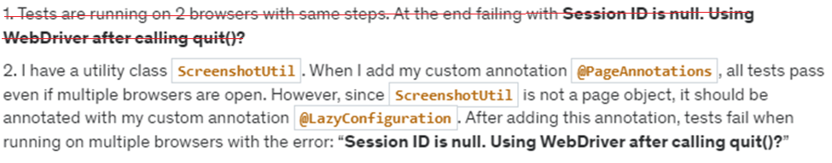

**This was raised at**

[**https://www.udemy.com/course/test-automation-framework/learn/lecture/20184658#questions/22212557**](https://www.udemy.com/course/test-automation-framework/learn/lecture/20184658#questions/22212557)

**Bean Scope Issue with ScreenshotUtil**

Tests were working fine if we run them without using ScreenshotUtil. With ScreenshotUtil, it is throwing an exception.

org.openqa.selenium.NoSuchSessionException: Session ID is null. Using WebDriver after calling quit()?

Build info: version: '4.22.0', revision: 'c5f3146703*'

System info: os.name: 'Windows 11', os.arch: 'amd64', os.version: '10.0', java.version: '22.0.1'

Driver info: org.openqa.selenium.chrome.ChromeDriver

**Once the browser is quit (driver.quit()) then, ScreenshotUtil won’t work.**



ScreenshotUtil instance

Webdriver instance

**Reason:**

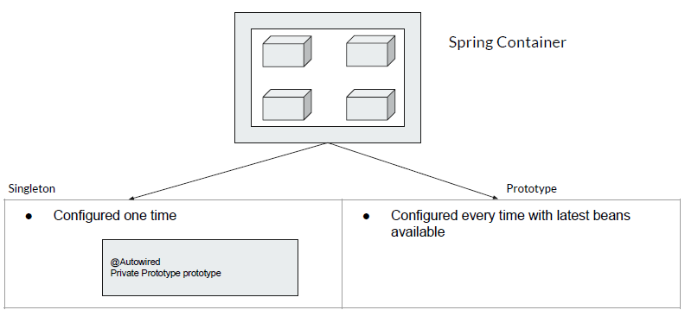

ScreenshotUtil

Spring will start creating all the beans and keep it inside the container. So whoever asked for it, it will give the bean to them.

ScreenshotUtil (Singleton Scope) depends on the webdriver instance because of this only we can take screenshot. So, 1st webdriver instance will be created inside Spring container (IoC) – 1 thread scope webdriver instance will be created. And, this will be present in spring container.

Now Spring will come at ScreenshotUtil, and say, hey ScreenshotUtil!, I am configuring you so what you need – Oh so you need webdriver instance. This instance I already have it my container. So Spring will take the thread scoped webdriver instance and put it inside ScreenshotUtil which in turn will create a ScreenshotUtil bean (Singleton Scoped Bean) and put this bean inside spring container.

Once a bean is created and it's a singleton scope, spring boot will simply forget it. Lifelong nobody will be touching/re-configuring the bean again and again. Since, Singleton is configured only 1-time. So the bean is created and it’s part of the container now.

Holding reference of WebDriver instance

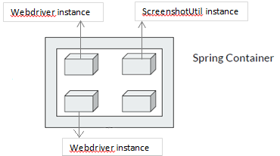

Now, as soon as driver.quit() is called in test-1, webdriver instance will be quit. But the ScreenshotUtil was holding the reference of this webdriver instance.

Later a new webdriver instance is created for test-2 but the ScreenshotUtil was holding reference of old webdriver instance. It has no reference of newly created webdriver instance. In test-2 execution, when we try to take the screenshot, ScreenshotUtil will say that, hey spring you gave me webdriver instance using which I am taking screenshot but it seems you quit the webdriver. Did you quit?

This problem can easily be fixed by adding @Scope(“prototype”) [Prototype scoped bean] which will be re-created again and again as part of every test run. Additionally, a new webdriver instance will also be created which will be tied to ScreenshotUtil as a reference. Spring boot will re-configure and put this ScreenshotUtil bean to container.



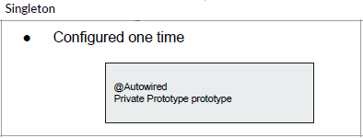

**ScreenshotUtil** Bean will always be **Singleton**!!

**The Spring ApplicationContext**

Before we dive deeper into the ApplicationContext container, it’s important to know about Spring beans. What Is a Spring Bean? 🡪 In Spring, a bean is an object that the Spring container instantiates, assembles, and manages.

*So should we configure all of the objects of our application as Spring beans? Well, as a best practice, we shouldn’t*.

The primary job of the ApplicationContext is to manage beans.

**Bean Management** in Spring Boot involves the creation, configuration, and lifecycle management of beans. The ApplicationContext is responsible for managing these beans.

### Usage:

### When to Use ApplicationContext in Spring Boot

1. **Bean Retrieval**: When you need to programmatically retrieve beans.



1. **Event Handling**: When you need to publish or listen to application events.



1. **Resource Loading**: When you need to load resources like files or properties.



1. **Internationalization**: When you need to resolve messages for different locales.



### When to Use @Component in Spring Boot

The @Component annotation is used to mark a class as a Spring-managed bean. It is a generic stereotype for any Spring-managed component and is often used for creating beans that do not fit into the more specific stereotypes like @Service, @Repository, or @Controller.

1. **General Bean Definition**: When you want Spring to automatically detect and register your bean.

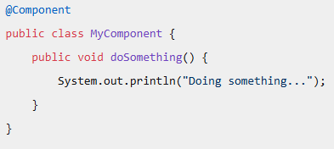

1. **Custom Annotations**: When creating custom annotations that include @Component as a meta-annotation.

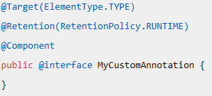

### Summary

* **Use ApplicationContext** when you need to interact with the Spring container programmatically, such as retrieving beans, handling events, loading resources, or resolving messages.
* **Use @Component** to define a Spring-managed bean that does not fit into the more specific stereotypes (@Service, @Repository, @Controller).

**The Spring ApplicationContext DEMO**

@Lazy   
@Component

public class ScreenshotUtil {  
 */**  
 * ISSUE - In the 1st run/execution "TakesScreenshot driver" will be quit and  
 * for the next run ScreenshotUtil won't hold reference of newly created "TakesScreenshot driver"  
 *  
 * TODO: We need to fix this issue!! --> ApplicationContext  
 */*// @Autowired  
// private TakesScreenshot driver;  
  
 @Autowired  
 private ApplicationContext ctx;  
  
 @Value("${screenshot.path}")  
 private Path fileWithPath;  
  
 @Autowired  
 private Faker faker;  
  
 public void takeScreenshot() {  
 try {  
 String currentWorkingDir = System.*getProperty*("user.dir");  
 System.*out*.println("Current working directory: " + currentWorkingDir);  
  
 // Call getScreenshotAs method to create image file  
// File SrcFile = this.driver.getScreenshotAs(OutputType.FILE); // *TODO: We need to fix the ISSUE --> ApplicationContext* // ctx.getBean() --> Get a bean that implements the TakesScreenshot interface.  
 // Here, I am sending a request to IoC container (Spring Container).  
 // Whenever I am going to take screenshot, at that time I am contacting spring container asking for a Bean of TakesScreenshot  
 // Hey spring container! do you have any Bean for me? --> Spring says, hey you are coming from x-thread and for this I have a WebDriver instance for you to use.  
 // So, ctx.getBean() comes into picture only when somebody calls takeScreenshot() method  
 File SrcFile = ctx.getBean(TakesScreenshot.class).getScreenshotAs(OutputType.*FILE*);  
  
 FileCopyUtils.*copy*(SrcFile, this.fileWithPath.resolve(faker.name().title() + ".png").toFile());  
 System.*out*.println("Screenshot is captured");  
 } catch (IOException e) {  
 throw new RuntimeException(e);  
 }  
 }  
}

**Summary of above code**

* **ctx.getBean()** --> Retrieve a bean that implements the TakesScreenshot interface.
* This line sends a request to the IoC container (Spring Container).
* As we all know that, several WebDriver implementations in Selenium support the TakesScreenshot interface.
  + **ChromeDriver**: Implements TakesScreenshot.
  + **FirefoxDriver**: Implements TakesScreenshot.
  + **InternetExplorerDriver**: Implements TakesScreenshot.
  + **EdgeDriver**: Implements TakesScreenshot.
  + **OperaDriver**: Implements TakesScreenshot.
* The **getBean()** method is used to retrieve a bean from the Spring container. By passing TakesScreenshot.class as an argument, you are asking the container to return a bean that implements the TakesScreenshot interface.
* Each time a screenshot is taken, it contacts the Spring container to get a bean.
* It's like asking the Spring container, "Do you have a bean for me?"
* The Spring container responds, "Yes, you're coming from x-thread, and I have a WebDriver instance ready for you."
* Therefore, **ctx.getBean() is invoked only when the takeScreenshot() method is called**.



Run the Tests again

**WebDriverFactory Using ApplicationContext**

*/\**

*When I say conditions, it means below  
* - @ConditionalOnProperty(name = "browser", havingValue = "firefox")  
* - @ConditionalOnMissingBean*

*/

public class WebDriverFactoryViaApplicationContext extends SpringBaseTestNGTests {  
 @Autowired  
 private ApplicationContext ctx;  
  
 @Test  
 public void browserTest() {  
 this.ctx.getBean("chromeDriver", WebDriver.class).get("https://www.google.com/");  
 this.ctx.getBean("chromeDriver", WebDriver.class).quit();  
 this.ctx.getBean("firefoxDriver", WebDriver.class).get("https://www.wikipedia.org/");  
 this.ctx.getBean("firefoxDriver", WebDriver.class).quit();  
 }  
}

This code demonstrates how to use Spring’s ApplicationContext to manage WebDriver instances for different browsers (Chrome and Firefox) and perform basic browser automation tasks within a TestNG test case.

**@Component Beans using Application Context**

Sometimes you might have an interface with multiple implementations, For ex: Car interface with Accord and Civic implementations.

If you need 1 instance dynamically using application context, then we have to do as shown here.

@Autowired

private ApplicationContext ctx;

...

...

Car car1 = this.ctx.getBean(Accord.class); // to get accord bean

Car car2 = this.ctx.getBean(Civic.class); // to get civic bean

**Suggestion:**

I would suggest you to go with Factory Pattern approach as that is the right way to do it in situations like this.

Let’s **Refactor the code**

* Create an annotation under annotation package 🡪 ThreadScopeBean

@Bean  
@Scope("browserscope")  
@Documented  
@Target({ElementType.*METHOD*})  
@Retention(RetentionPolicy.*RUNTIME*)   
public @interface ThreadScopeBean {}

* Replace @Bean and @Scope from WebDriverConfig, RemoteWebDriverConfig with this ThreadScopeBean annotation

@ThreadScopeBean  
@ConditionalOnProperty(name = "browser", havingValue = "firefox")  
public WebDriver remoteFirefoxDriver() {  
 return new RemoteWebDriver(this.url, new FirefoxOptions());  
}

@ThreadScopeBean  
@ConditionalOnMissingBean  
public WebDriver remoteChromeDriver() {  
 return new RemoteWebDriver(this.url, new ChromeOptions());  
}

@ThreadScopeBean  
@ConditionalOnProperty(name = "browser", havingValue = "firefox")  
public WebDriver firefoxDriver() {  
 WebDriverManager.*firefoxdriver*().setup();  
 return new FirefoxDriver();  
}

@ThreadScopeBean  
@ConditionalOnMissingBean  
public WebDriver chromeDriver() {  
 WebDriverManager.*chromedriver*().setup();  
 return new ChromeDriver();  
}

* Create a new package by name spring_configurations and put config,util,annotation folders under this package.

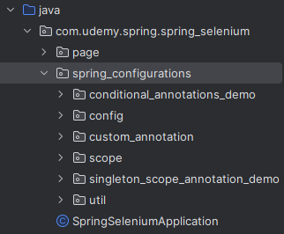

* Rename ScreenshotUtil 🡪 ScreenshotService
* Replace annotation of ScreenshotService as

@Lazy

@Service

* Create a custom annotation 🡪 LazyAutowired

@Lazy  
@Autowired  
@Documented  
@Target({ElementType.*FIELD*})  
@Retention(RetentionPolicy.*RUNTIME*)   
public @interface LazyAutowired {}

* Replace all tests with above annotation

// @Lazy  
// @Autowired  
 @LazyAutowired  
 private RedBusPage redBusPage;  
  
// @Lazy  
// @Autowired  
 @LazyAutowired  
 private ScreenshotService screenshotUtil;

// @Lazy  
// @Autowired  
 @LazyAutowired  
 private GooglePage googlePage;  
  
// @Lazy  
// @Autowired  
 @LazyAutowired  
 private ScreenshotService screenShotUtil;  
  
// @Lazy  
// @Autowired  
 @LazyAutowired  
 private LoggerConfig loggerConfig;

* Refactor WebDriverWaitConfig

@LazyConfiguration  
public class WebDriverWaitConfig {  
 @Value("${default.timeout:30}")  
 private int timeout;  
@Bean  
 public WebDriverWait webdriverWait(WebDriver driver){  
 return new WebDriverWait(driver, Duration.*ofSeconds*(this.timeout));  
 }  
}

Here, default scope is Singleton. We have now 2 scopes available.

* @Scope(“prototype”)
* ThreadScopeBean

We cannot use ThreadScopeBean here as it is tightly coupled with WebDriver. Also, there is no way to check if this WebDriverWait is really usable or not as we did while creating BrowserScope.

So, let’s annotate with

@Scope(ConfigurableBeanFactory.SCOPE_PROTOTYPE)

@Bean  
@Scope(ConfigurableBeanFactory.*SCOPE_PROTOTYPE*)  
public WebDriverWait webdriverWait(WebDriver driver){  
 return new WebDriverWait(driver, Duration.*ofSeconds*(this.timeout));  
}

**Why we didn’t have any issues with Singleton scope of WebDriverWait ?**

In each page classes like GooglePage, SearchComponent, SearchResultComponent anywhere we are not using WebDriverWait at all. We were using only webdriver instance not WebDriverWait. If we would have used it then we would have an issue here.

So it should be whenever the page object is created, we need one webdriver wait instance for the corresponding webdriver So let's create a fresh instance for this.

**What is the difference between ApplicationContext and BeanFactory?**

**ApplicationContext** and **BeanFactory** are both interfaces in the Spring framework that represent the Inversion of Control (IoC) container, but they serve different purposes and have different levels of functionality.

**BeanFactory**

* **Basic Container**: BeanFactory is the simplest container providing basic Dependency Injection (DI) capabilities.
* **Lightweight**: It is lightweight and **suitable for simple applications where memory consumption is a concern**.
* **Lazy Initialization**: Beans are created only when they are needed/requested, which can save resources. Lazy initialization means that a bean is created only when it is requested for the first time, rather than at the startup of the application.
* **Limited Features**: It lacks advanced features like event propagation, internationalization, and AOP (Aspect-Oriented Programming).
* **Custom Bean Creation Logic**: In cases where you need custom logic for bean creation that does not fit well with the declarative style of **ApplicationContext**, **BeanFactory** provides a more flexible approach. You can programmatically control the creation and configuration of beans

**ApplicationContext**

* **Advanced Container:** ApplicationContext extends BeanFactory and adds more enterprise-centric features.
* **Eager Initialization: By default, it creates all singleton beans at startup**, which can lead to faster performance at runtime.
* **Rich Features:** It supports event propagation, internationalization, AOP, and more**.**
* **Convenience:** Provides several convenient methods for accessing beans, resources, and application events.

In summary, **BeanFactory** is suitable for simple, lightweight applications, while **ApplicationContext** is more feature-rich and suited for enterprise-level applications requiring advanced functionalities.

For most modern Spring applications, **ApplicationContext** is preferred due to its rich set of features and ease of use. It provides a more comprehensive solution for enterprise-level applications with advanced requirements like event handling, internationalization, and AOP.

### **BeanFactory Vs FactoryBean**

* **What it is**: BeanFactory is the core interface of the Spring Framework for managing and obtaining instances of beans.
* **Role**: It acts as a container that holds bean definitions and instantiates them when requested.
* **Use Case**: It’s used to create and manage beans in a lightweight manner, suitable for simple applications or memory-constrained environments.

### **FactoryBean**

* **What it is**: FactoryBean is a special type of bean that acts as a factory for creating other beans.
* **Role**: It allows for more customization during the creation of a bean. By implementing the FactoryBean interface, you can add complex logic or additional processing before the bean is instantiated.
* **Use Case**: It’s used when you need to create complex beans or perform additional logic during bean creation.

### Key Difference

* **BeanFactory** is a container that manages beans.
* **FactoryBean** is a bean that creates other beans.

**Summary**

● Bean Scope

○ Singleton

○ Prototype

○ ThreadScope - custom scope. We have to register ourselves!

● Parallel Browser Testing

● ApplicationContext

○ To get bean ourselves

○ getBean(“method”, WebDriver.class)

● WebDriverFactory - Managed by Spring & You

● Custom Annotations

○ We will do something cool with this!!

● **spring_configuration** package…………..!!!! 🡪 Refactoring

### **Spring Boot & Selenium - Files & Properties**

* **Accessing Resources**

|  |  |
| --- | --- |
| **Prefix** | **Example** |
| classpath | classpath:data/udemy.txt |
| file: | file:c:/some/path/udemy.txt |
| http: | http://somesite.com/udemy.txt |

**Note**:

* 1. If files are part of your project then always use **classpath** instead of src/test/resources… It creates trouble while packaging the project.
  2. If files are a part of project but in file-system then use **file**

**Demo**:-

1. Create a directory (folder) of resource type by name “resources” under test



1. Create a folder 🡪 data
2. Create a .csv file under data folder
3. Create a package under test/java/spring-selenium 🡪resourcesAccessTests
4. Write a class 🡪 ResourceTest.java

public class ResourceTest extends SpringBaseTestNGTests {  
 @Value("classpath:data/testdata.csv") // File is a part of project  
 private Resource classPathResource;  
  
 // File is not part of project instead external file-system (not within project)  
 @Value("file:\\SeleniumTestAutomationWithSprintBoot\\udemy-spring-selenium\\spring-selenium\\testdata.csv")  
 private Resource filePathResource;  
  
 @Value("https://www.w3.org/Graphics/GIF/spec-gif89a.txt") // File is a part of website  
 private Resource webPathResource;  
 @Value("${file.path}/some.txt")  
 private Path path;  
  
 @Test  
 public void readResourceData1() throws IOException {  
 Files.*readAllLines*(classPathResource.getFile().toPath())  
 .forEach(System.*out*::println);  
 }  
  
 @Test  
 public void readResourceData2() throws IOException {  
 Files.*readAllLines*(filePathResource.getFile().toPath())  
 .forEach(System.*out*::println);  
 }  
  
 */**  
 * The method reads data from webPathResource, prints it to the console, and then copies the same data to a file specified by path  
 * Basically we are downloading file from a webpage  
 *  
 * @throws IOException  
 */* @Test  
 public void readResourceData3() throws IOException {  
 */**  
 * webPathResource.getInputStream(): Obtains an InputStream from the webPathResource.  
 * readAllBytes(): Reads all bytes from the InputStream into a byte array.  
 */* System.*out*.println(new String(webPathResource.getInputStream().readAllBytes()));  
  
 */**  
 * Copies the data from the InputStream to the OutputStream.  
 *  
 * webPathResource.getInputStream(): Again, obtains an InputStream from the webPathResource.  
 * Files.newOutputStream(path): Creates an OutputStream to the specified file path.  
 * FileCopyUtils.copy(...): Copies the data from the InputStream to the OutputStream.  
 */* FileCopyUtils.*copy*(webPathResource.getInputStream(), Files.*newOutputStream*(path)); // Copying resource data to a file  
 }  
}

* 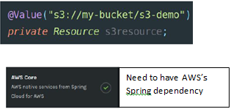**AWS S3 Resources**

We could easily access S3 resources as well

* No additional code required
* We need to include AWS core dependency
* (You should have the permission)
* **ResourceLoader for Dynamic Resources**
* **To get resources at runtime (similar to application context to get beans at runtime)**

Sometimes, the path might need to be dynamic.

For instance, while we were auto-wiring the WebDriver, we also had the flexibility to use the application context to getBean() at runtime.

Similarly, is there an alternative way to access files at runtime instead of always relying on the annotation-based approach? – Yes!

@Value("classpath:data/dynamicdata.csv") // File is a part of project  
private Resource dynamicResource;

@Value("${file.path}")  
private Path path1;

@Autowired  
private ResourceLoader resourceLoader;

*/**  
 * The getData() method reads data from a file, splits each line by commas, and returns it as a two-dimensional array of Object.  
 * @return  
 * @throws IOException  
 */*@DataProvider  
public Object[][] getData() throws IOException {  
 return Files.*readAllLines*(dynamicResource.getFile().toPath())  
 .stream()  
 .map(s -> s.split(","))  
 .toArray(Object[][]::new);  
}  
  
@Test(dataProvider = "getData")  
public void readDynamicResourceData(String url, String saveAs) throws IOException {  
 */**  
 * resourceLoader.getResource(url).getInputStream(): Obtains an InputStream from the resource specified by the url.  
 * Files.newOutputStream(path.resolve(saveAs)): Creates an OutputStream to the file specified by saveAs in the path directory.  
 * FileCopyUtils.copy(...): Copies the data from the InputStream to the OutputStream  
 */* FileCopyUtils.*copy*(  
 resourceLoader.getResource(url).getInputStream(),  
 Files.*newOutputStream*(path1.resolve(saveAs))  
 );  
}

* **PropertiesLoaderUtils**
* **To load N number of property files at runtime!**

If you have a large number of property files, you can load them all at runtime using a data provider or utility. Simply use PropertiesLoaderUtils.loadProperties(fileName) to read each file. These files can be part of your classpath or located outside the project.

public class Propertes extends SpringBaseTestNGTests {  
 @Autowired  
 private ResourceLoader resourceLoader;  
  
 @Test  
 public void readProperties() throws IOException {  
 */**  
 * The loadProperties method reads the properties from the given resource and loads them into a Properties object.  
 * This method handles the input stream and ensures the properties are correctly loaded.  
 */* Properties props = PropertiesLoaderUtils.*loadProperties*(  
 resourceLoader.getResource("data/my.properties") // This part of the code uses the resourceLoader to get a resource located at "data/my.properties".  
 );  
 System.*out*.println(props);  
 }  
}

* **@PropertySource**

In the previous demo, we loaded properties using PropertiesLoaderUtils, which returned a properties object. This object functions like a map with key-value pairs. If you prefer this approach, you can continue using it. Alternatively, you can also place everything in application.properties and inject it wherever needed.

However, using @Value annotations to inject properties can sometimes be problematic. For instance, if you need the {file.path} in multiple places, or any other property, you might inject it into more than one class. The issue with this approach is the potential for misspelling the string {file.path}. Additionally, if you need to change the key (e.g., from {file.path} to something else), you would have to update all the classes, which can be quite tedious.

Instead of injecting values in multiple places, Spring Boot allows you to create a single model. You can define a class with your properties and use the **@PropertySource** annotation to manage them.

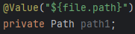

|  |  |
| --- | --- |
| To read any additional property files which are not part of application.properties. |  |
| Instead of injecting values in multiple places, just inject once! |
| Properties into a Java object! |

**Google Flight Application – Requirement**

Website = <https://www.google.com/travel/flights>

Flight search and booking system at Google Flights

User Interface

* Search Functionality: Allow users to search for flights by entering departure and destination locations.
* Date Selection: Provide a calendar for selecting travel dates.
* Passenger Details: Options to specify the number of passengers and their cabin class.
* Flight Listings: Display a list of available flights with details such as airline, departure and arrival times, duration, and price.
* Filters: Enable users to filter results by criteria like number of stops, airlines, price range, and flight duration.
* Price Tracking: Feature to track flight prices and notify users of changes.
* 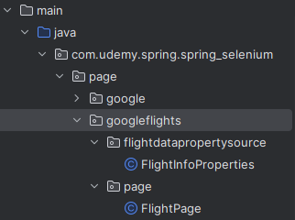Booking Links: Direct users to airline or travel agency websites for booking.

Steps:

1. Create a package under test/resources 🡪 GoogleFlightLocale
2. Create 2 properties file inside it 🡪 en.properties/id.properties
3. Create a class 🡪 FlightInfoProperties.java

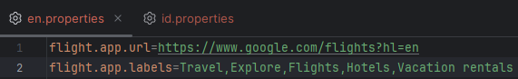

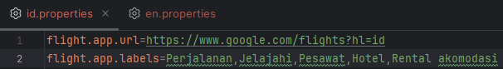

@Component  
**@PropertySource**("GoogleFlightLocale/**en.properties**")  
public class FlightInfoProperties {  
 @Value("flight.app.url")  
 private String url;  
  
 @Value("flight.app.labels")  
 private List<String> labels;  
  
 public String getUrl() {  
 return url;  
 }  
  
 public List<String> getLabels() {  
 return labels;  
 }  
}

1. Create a page 🡪 FlightWebPage.java

@PageAnnotations  
public class FlightWebPage extends Base {  
 private JavascriptExecutor jse;  
 @FindBy(css = "[aria-label='Flight']")  
 private WebElement flightSearch;  
 @FindBy(xpath = ".//*[@data-is-touch-wrapper='true']//*[@role='link']//span")  
 private List<WebElement> buttons;  
  
 @Override  
 public boolean isAt() {  
 jse = (JavascriptExecutor) driver;  
 boolean isLoaded = this.webDriverWait.until((d) -> jse.executeScript("document.readyState").equals("complete"));  
 boolean isNotEmpty = this.webDriverWait.until((d) -> !this.buttons.isEmpty());  
 return (isLoaded && isNotEmpty);  
 }  
  
 public List<String> getLabels() {  
 return this.buttons.stream().map(WebElement::getText) .filter(Objects::*nonNull*).map(String::trim).collect(Collectors.*toList*()); }}

1. Create a test class 🡪 FlightTest.java

public class FlightTest extends SpringBaseTestNGTests {  
 @Autowired  
 private FlightInfoProperties flightInfoProperties;  
   
 @Autowired  
 private FlightWebPage flightPage;  
  
 @Test  
 public void flightTest() {  
 this.flightPage.goTo(this.flightInfoProperties.getUrl());  
 Assert.*assertTrue*(this.flightPage.isAt());  
 Assert.*assertEquals*(this.flightPage.getLabels(), this.flightInfoProperties.getLabels());  
 }  
}

1. Run the Test

====================================================

Default Suite

Total tests run: 1, Passes: 1, Failures: 0, Skips: 0

====================================================

### **Localization Testing via Command Line**

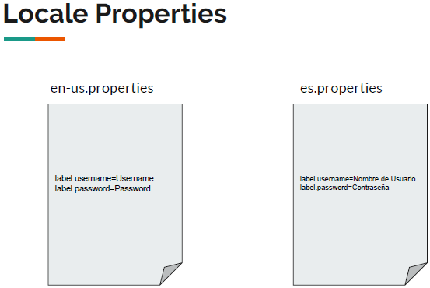

Let’s not hard-code GoogleFlightLocale/id.properties or GoogleFlightLocale/en.properties

@Component  
@PropertySource("GoogleFlightLocale/${app.locale}.properties")

public class FlightInfoProperties {…}

Edit the configuration & run the test

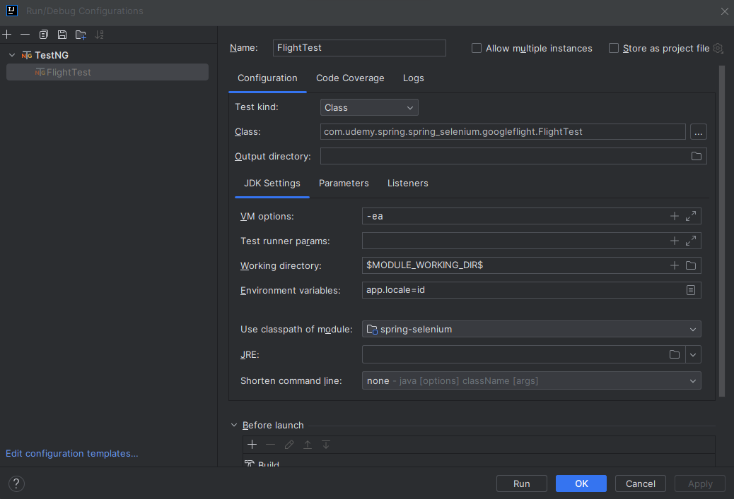

====================================================

Default Suite

Total tests run: 1, Passes: 1, Failures: 0, Skips: 0

====================================================

**@TestPropertySource**

Sometimes if you have a requirement like as part of a 1 test run, I would like to validate to different language. In this case, we can also use PropertiesLoaderUtils to load properties at runtime. Additionally there is another approach by using @TestPropertySource annotation.

The @TestPropertySource annotation in Spring Boot is used to specify property sources for integration tests. It allows you to define properties files or inlined properties that will be added to the set of PropertySources in the Environment for an ApplicationContext loaded for an integration test. This annotation is **applied at the class level** to configure the locations of properties files or inlined properties. You can specify the location of a properties file that contains the properties you want to use in your tests.

Create 2 test classes 🡪 EnglishTest.java | IndonesianTest.java

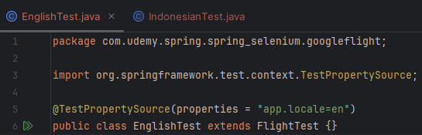

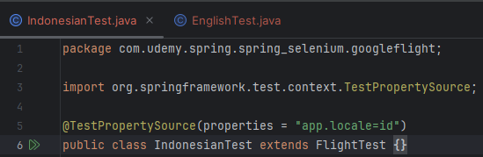

Let’s 2 tests at same time

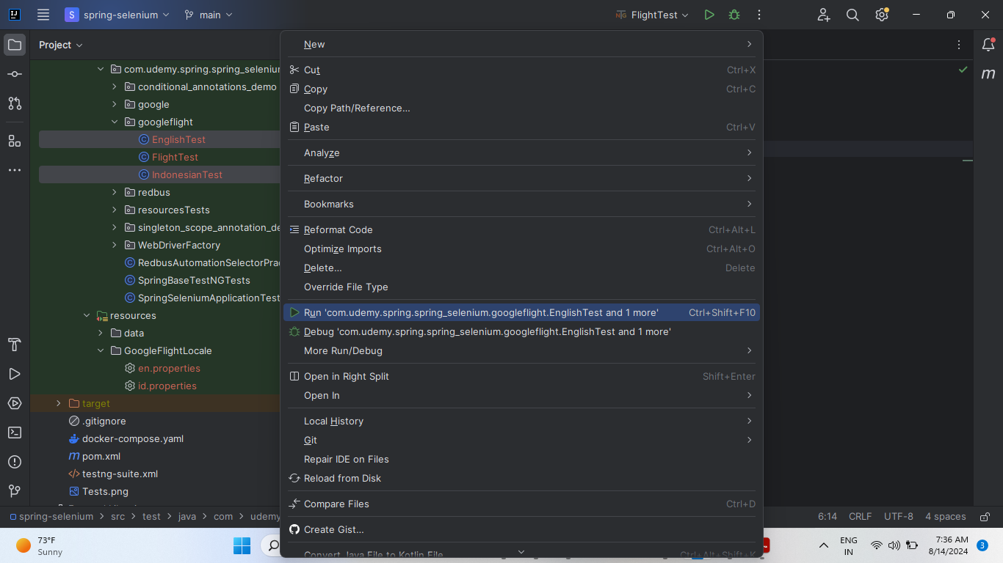

So, here, **@TestPropertySource is basically changing the property at runtime just for the test**.

We can also write like this to say run 1 of my test in firefox

@TestPropertySource(properties = {"app.locale=id", **"browser=firefox"**})  
public class IndonesianTest extends FlightTest {}

Run the test

====================================================

Default Suite

Total tests run: 1, Passes: 1, Failures: 0, Skips: 0

====================================================

### **Spring Boot & Selenium - Aspect Oriented Programming**

**Cross-Cutting concerns**

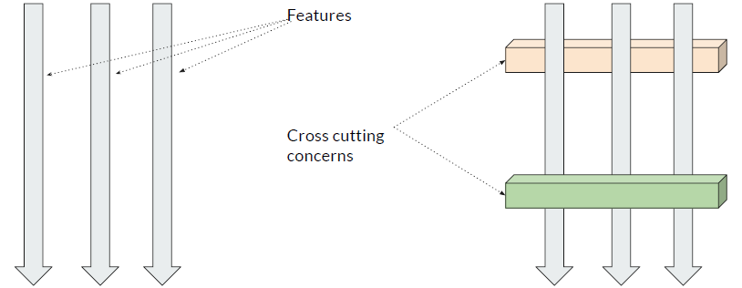

Cross-cutting concerns in Spring Boot refer to aspects of a program that affect multiple layers or components, such as logging, security, transaction management, and error handling. These concerns are not part of the core business logic but are essential for the applications overall functionality and maintainability.

In Spring Boot, these concerns are typically managed using **Aspect-Oriented Programming (AOP)**. AOP allows you to define aspects, which are modular units of cross-cutting concerns. Here are some key concepts:

* **Aspect**: A module that encapsulates a concern that cuts across multiple classes.
* **Joinpoint**: A point during the execution of a program, such as method execution or exception handling.
* **Pointcut**: A predicate that matches join points. Advice is associated with a pointcut expression and runs at any join point matched by the pointcut.
* **Advice**: The action taken by an aspect at a particular joinpoint. Types of advice include "around," "before," and "after."
* **Proxy**: The object created by the framework after applying the advice on the target object.
* **Target**: The application object on which the advice is applied.

By using AOP, you can keep your business logic clean and separate from these cross-cutting concerns, making your code more modular and easier to maintain.

In simple terms,

Cross-cutting concerns in Spring Boot are aspects of a program that affect multiple parts of the application. Think of them as common tasks that you need to handle in many places, but they aren’t part of the main business logic. Here are some simple examples:

* **Logging**: Keeping track of what the application is doing.
* **Security**: Ensuring that only authorized users can access certain parts of the application.
* **Transaction Management**: Making sure that a series of operations either all succeeds or all fail, to keep data consistent.
* **Error Handling**: Managing what happens when something goes wrong.
* **Performance Monitoring**: For performance-critical applications, you might need to monitor the execution time of various methods. AOP allows you to measure and log performance metrics without cluttering your business logic.

For example, in an e-commerce application, you might use AOP to handle logging and security:

* **Logging**: Automatically log every time a user adds an item to their cart, checks out, or views an order history.
* **Security**: Ensure that only authenticated users can access the checkout process or view order histories.

In Spring Boot, these are managed using Aspect-Oriented Programming (AOP). AOP allows you to define these common tasks separately and then apply them across different parts of your application without cluttering your main code.

**Requirement:** [**https://vins-udemy.s3.amazonaws.com/ds/window/main.html**](https://vins-udemy.s3.amazonaws.com/ds/window/main.html)

**Multiple Windows**

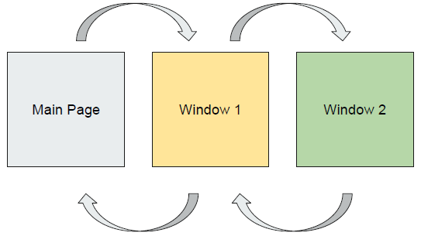

Create a class under utils folder 🡪 WindowsSwitchService.java

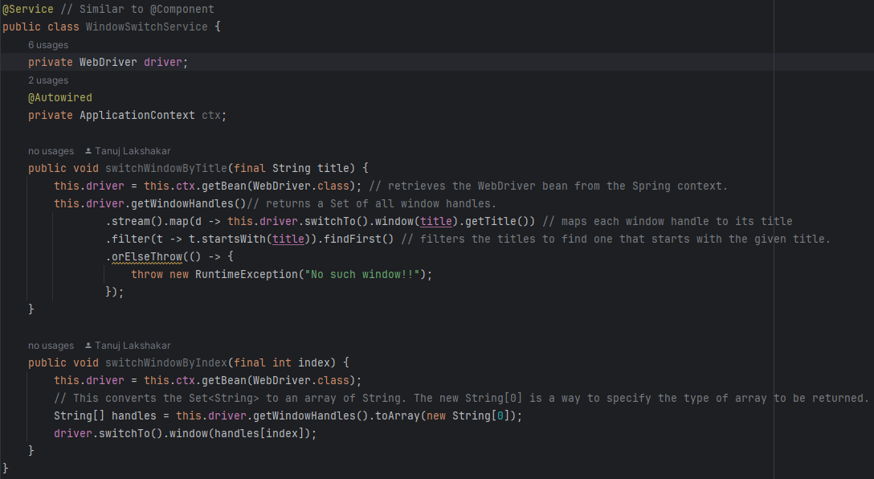

Create PageObjects 🡪 MainPage, PageA, PageB, PageC

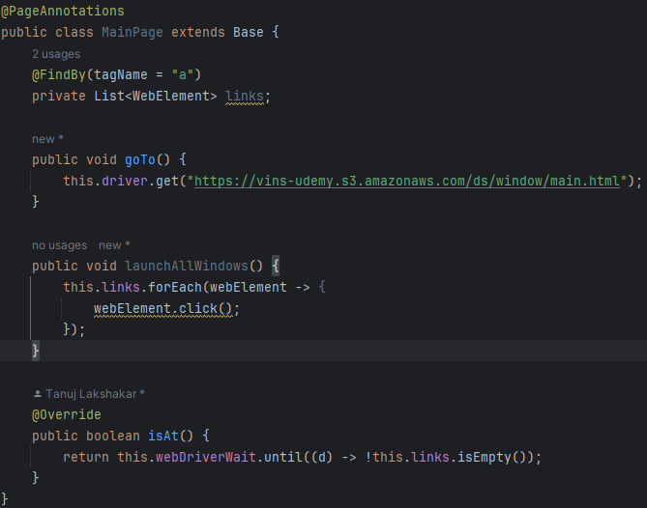

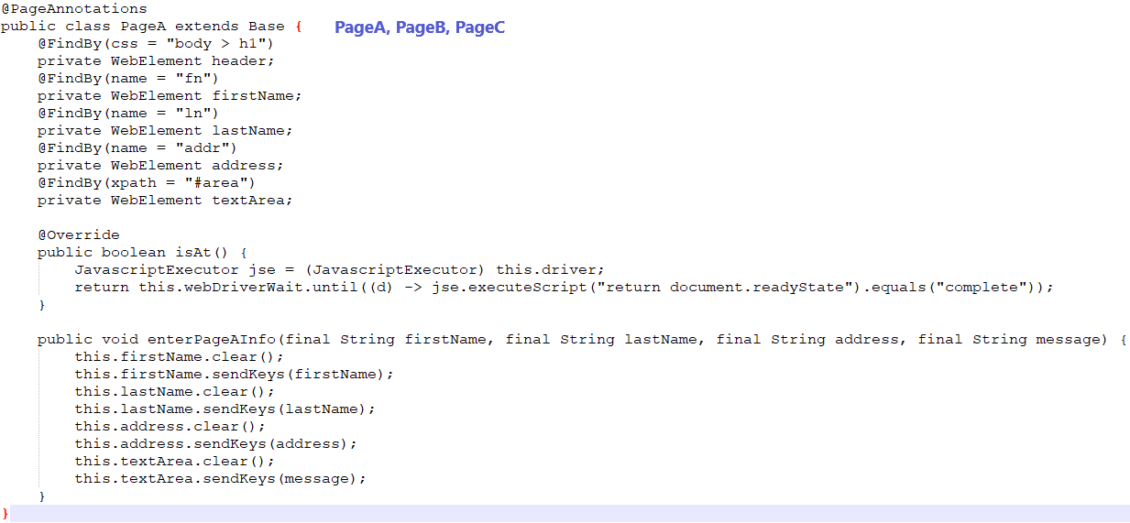

Create Test 🡪 WindowSwitchTest.java

@TestPropertySource(properties = "browser=firefox")  
public class WindowSwitchTest extends SpringBaseTestNGTests {  
 @Autowired  
 private MainPage mainPage;  
 @Autowired  
 private PageA pageA;  
 @Autowired  
 private PageB pageB;  
 @Autowired  
 private WindowSwitchService windowSwitchService;  
 @Autowired  
 private Faker faker; // It is a bean  
 //Faker faker = new Faker(); // No need as we already created FakerConfig to allow Spring to manage it  
  
 @BeforeSuite  
 public void beforeSuite() {  
 */**  
 * None of objects defined will be available if we try to access them inside before suite  
 * At this point they would not have been injected by Spring  
 */* }  
 @BeforeTest  
 public void beforeText() {  
 */**  
 * None of objects defined will be available if we try to access them inside before test  
 * At this point they would not have been injected by Spring  
 */* }  
  
 @BeforeClass  
 public void setup() {  
 this.mainPage.goTo();  
 this.mainPage.isAt();  
 this.mainPage.launchAllWindows();  
 }  
  
 @Test  
 public void switchWindowTest() {  
 this.windowSwitchService.switchWindowByTitle("Page A");  
 this.pageA.enterPageAInfo(  
 this.faker.name().firstName(),  
 this.faker.name().lastName(),  
 this.faker.address().fullAddress(),  
 "Hi! Page A"  
 );  
 this.windowSwitchService.switchWindowByIndex(2);  
 this.pageB.enterPageBInfo(  
 this.faker.name().firstName(),  
 this.faker.name().lastName(),  
 this.faker.address().fullAddress(),  
 "Hello! Page B"  
 );  
 }  
}

**Custom @Window for Aspect Oriented Programming**

Let’s implement Aspect Oriented Programming

* Go to pom.xml
* Add dependency

<dependency>  
 <groupId>org.springframework.boot</groupId>  
 <artifactId>spring-boot-starter-aop</artifactId>  
 ~~<version>3.3.1</version>~~  
</dependency>

* Create an annotation under

com.udemy.spring.spring_selenium.spring_configurations.custom_annotation 🡪 WindowAnnotations

@Lazy  
@Component  
@Scope(ConfigurableBeanFactory.*SCOPE_PROTOTYPE*)  
@Documented  
@Target({ElementType.*TYPE*})  
@Retention(RetentionPolicy.*RUNTIME*)   
public @interface WindowAnnotations { String value() default ""; }

* Replace @PageAnnotations with @WindowAnnotations for each page Page A,Page B,Page C

//@PageAnnotations  
@WindowAnnotations("Page A") // AOP - Aspect Oriented Programming  
public class PageA extends Base {…}

//@PageAnnotations  
@WindowAnnotations("Page B") // AOP - Aspect Oriented Programming  
public class PageB extends Base {…}

//@PageAnnotations  
@WindowAnnotations("Page C") // AOP - Aspect Oriented Programming  
public class PageC extends Base {…}

* Create a package under src/main/java/com.udemy.spring.spring_selenium.spring_configurations 🡪 aspect_orient_programming
* Create a class inside this folder 🡪 WindowAspect.java

@Aspect  
@Service  
public class WindowAspect {  
 @Autowired  
 private WindowSwitchService switchService;  
  
 @Before("@target(window) && within(com.udemy.spring.spring_selenium..*)")  
 public void before(WindowAnnotations window){  
 System.*out*.println("Before -- Any class that has WindowAnnotations. I will be triggered.");  
 System.*out*.println("This means that any of method in the class that has WindowAnnotations is going to be executed, before that this method would be triggered automatically");  
 this.switchService.switchWindowByTitle(window.value());  
 }  
  
@After("@target(window) && within(com.udemy.spring.spring_selenium..*)")  
 public void after(WindowAnnotations window){  
 System.*out*.println("After -- Any class that has WindowAnnotation. I will be triggered.");  
 System.*out*.println("This implies that any method within the class annotated with WindowAnnotations will execute, and subsequently, this method will be automatically triggered.");  
 this.switchService.switchWindowByIndex(0);   
 }  
}

* Create test class 🡪 WindowSwitchServicwWithAOP.java

@TestPropertySource(properties = "browser=chrome")  
public class WindowSwitchServiceWithAOP extends SpringBaseTestNGTests {  
 @Autowired  
 private MainPage mainPage;  
 @Autowired  
 private PageA pageA;  
 @Autowired  
 private PageB pageB;  
 @Autowired  
 private PageC pageC;  
 @Autowired  
 private Faker faker;

@BeforeSuite  
 public void beforeSuite() {  
 }  
 @BeforeTest  
 public void beforeText() {  
 }  
  
 @BeforeClass  
 public void setup() {  
 this.mainPage.goTo();  
 this.mainPage.isAt();  
 this.mainPage.launchAllWindows();  
 }  
  
 @Test(dataProvider = "getData")  
 public void switchWindowTest(int number) {  
 this.pageA.enterPageAInfo(  
 this.faker.name().firstName(),  
 this.faker.name().lastName(),  
 this.faker.address().fullAddress(),  
 (number * 1) + "\n"  
 );  
 this.pageB.enterPageBInfo(  
 this.faker.name().firstName(),  
 this.faker.name().lastName(),  
 this.faker.address().fullAddress(),  
 (number * 2) + "\n"  
 );  
 this.pageC.enterPageCInfo(  
 this.faker.name().firstName(),  
 this.faker.name().lastName(),  
 this.faker.address().fullAddress(),  
 (number * 3) + "\n"  
 );  
 }  
  
 @DataProvider  
 public Object[][] getData(){  
 return new Object[][] { {3},{4},{1},{5},{6},{2} };  
 }  
}

Run the test it **PASSED**

So,

Page A, Page B, Page C

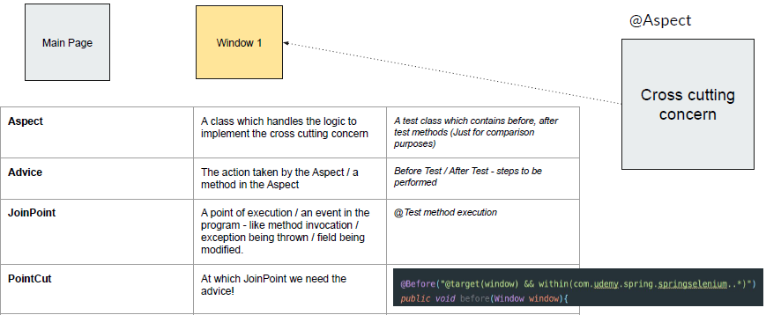

WindowAspect

Contains MainPage functionality. Page A, Page B, Page C related functionalities are here.

Our aim was to move from MainPage to Page A/B/C. @Aspect (Cross cutting concern) class containing the logic to switch to multiple windows.

**Reference**: [Aspect Oriented Programming](https://docs.spring.io/spring-framework/docs/2.0.x/reference/aop.html)

**AOP - Sample PointCut Expressions**

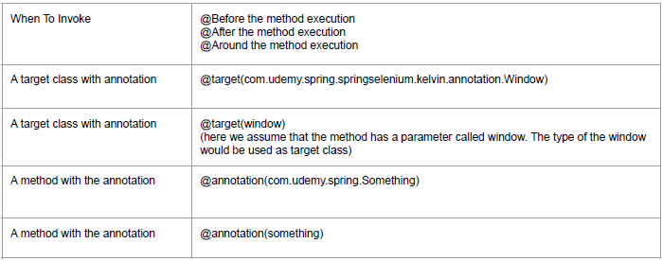

**Assignment Requirement** – When getLabel() is called take screenshot.

* Create a custom annotation for taking screenshot 🡪 TakeScreenshotAnnotation
* Place this annotation at getLabel()
* Create an Aspect 🡪 ScreenshotServiceAspect
* Aspect should have a condition which says if any method has annotation @TakeScreenshotAnnotation then invoke aspect

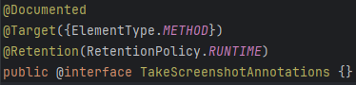

@PageAnnotations  
public class FlightWebPageWithAOP extends Base {  
 private JavascriptExecutor jse;  
 @FindBy(css = "[aria-label='Flight']")  
 private WebElement flightSearch;  
 @FindBy(xpath = ".//*[@data-is-touch-wrapper='true']//*[@role='link']//span")  
 private List<WebElement> buttons;  
  
 @Override  
 public boolean isAt() {  
 jse = (JavascriptExecutor) driver;  
 boolean isLoaded = this.webDriverWait.until((driver) -> jse.executeScript("return document.readyState").equals("complete"));  
 boolean isNotEmpty = this.webDriverWait.until((d) -> !this.buttons.isEmpty());  
 return (isLoaded && isNotEmpty);  
 }  
  
 @TakeScreenshotAnnotations  
 public List<String> getLabels() {  
 return this.buttons.stream()  
 .map(WebElement::getText)   
 .filter(Objects::*nonNull*)  
 .map(String::trim)   
 .collect(Collectors.*toList*());  
 }  
  
 public void goTo(final String url) {  
 this.driver.get(url);  
 this.driver.manage().window().maximize();  
 }  
  
 public void close() {  
 this.driver.quit();  
 }  
}

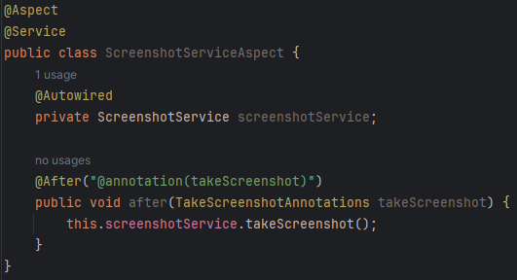

**Run** EnglishTest/IndonesianTest

**Summary**

● AOP

● Cross cutting concern

○ Separate core and secondary concerns

● Window Switch

● Frame Switch

● Taking Screenshot

● Logging

● Re-execute the method if the result is not as expected

● Do a data setup / make a REST call before method/after method invocation

### **Spring Boot - Data JPA**

Spring Boot and Spring Data JPA make it easier to build applications that interact with databases. It helps you avoid writing a lot of boilerplate code.

The java persistence API provides a specification for persisting, reading, and managing data from your java object to your relational tables in the database. Spring Data JPA is not a JPA provider; it is a library/framework that adds an extra layer of abstraction on the top of our JPA provider line Hibernate.

* JPA - Java Persistence API
* Provides a nice abstraction to connect to various SQL/NoSQL Databases
* Do not write a single line of SQL (Hibernate lib)
* Select / Insert / Update / Delete
* Where / Aggregation

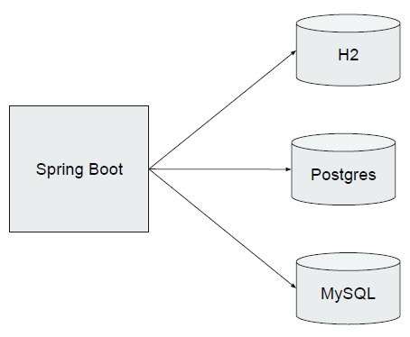

We’ll use H2 here, which is **in-memory relational DB** very useful for testing purpose.

### **How It Works**

* **Entities**: These are simple Java objects (POJOs) that represent data in your database. Each entity corresponds to a table, and each field in the entity corresponds to a column in the table.

@Entity 🡪 This annotation defines that a class can be mapped to a table

public class User {

@Id 🡪 This annotation specifies the primary key of the entity.

@GeneratedValue(strategy = GenerationType.IDENTITY) 🡪 This annotation is used to specify the primary key generation strategy to use. i.e. Instructs database to generate a value for this field automatically. If the strategy is not specified by default AUTO will be used

private Long id;

private String name;

private String email;

// Getters and Setters

}

* **Repositories**: These are interfaces that extend JpaRepository and provide CRUD (Create, Read, Update, Delete) operations for your entities without writing any implementation code.

public interface UserRepository extends JpaRepository<User, Long> {

List<User> findByName(String name);

}

* **Service Layer**: This layer contains business logic and interacts with the repository to perform operations.

@Service

public class UserService {

@Autowired

private UserRepository userRepository;

public List<User> getUsersByName(String name) {

return userRepository.findByName(name);

}

}

* **Controller**: This is the layer that handles HTTP requests and responses. It uses the service layer to get data and send it back to the client.

@RestController 🡪 This is a Spring annotation that is used to build REST API in a declarative way. RestController annotation is applied to a class to mark it as a request handler, and Spring will do the building and provide the RESTful web service at runtime.

@RequestMapping("/users")

public class UserController {

@Autowired

private UserService userService;

@GetMapping("/name/{name}") 🡪 This annotation is a specialized version of @RequestMapping annotation that acts as a shortcut for @RequestMapping(method = RequestMethod. GET). The @GetMapping annotated methods in the @Controller annotated classes handle the HTTP GET requests matched with the given URI expression.

public List<User> getUsersByName(@PathVariable String name) {

return userService.getUsersByName(name);

}

}

### **Putting It All Together**

* **Entity**: Represents the data.
* **Repository**: Provides methods to interact with the data.
* **Service**: Contains business logic.
* **Controller**: Handles web requests.

This setup allows you to easily create, read, update, and delete data in your database with minimal code.

### **Spring Data in Testing**

Using Spring Data in testing is crucial for ensuring that your data access layer works correctly. Here are some scenarios and tools for when and how to use Spring Data in testing:

* Data Driven Tests
* Query test data
* Let spring handle routine activities!
* CSV → Table

### **When to Use Spring Data in Testing**

1. **Unit Testing Repositories**: To verify that your repository methods work as expected.
2. **Integration Testing**: To ensure that your application components work together correctly, including database interactions.
3. **Testing Custom Queries**: To validate that custom queries return the expected results.
4. **Performance Testing**: To check the performance of your database operations

### **Spring Data JPA – Basics**

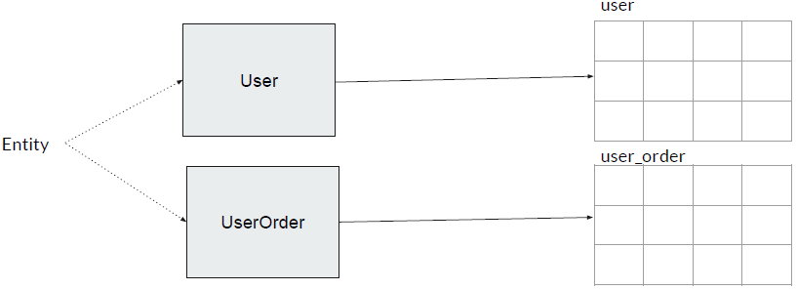

We will have n number of tables here I have a user table and a user_order table. We usually create at least 1 Java class per table in the database. Okay, so it's a kind of a 1-to-1 mapping.

If the user table has 10 columns like first name, last name, middle name, etc., then I will be having those fields in the class to map. That means, tables are mapped by classes and the columns are mapped by fields in the classes; kind of simple 1-to-1 mapping and these classes are called **Entity** classes.

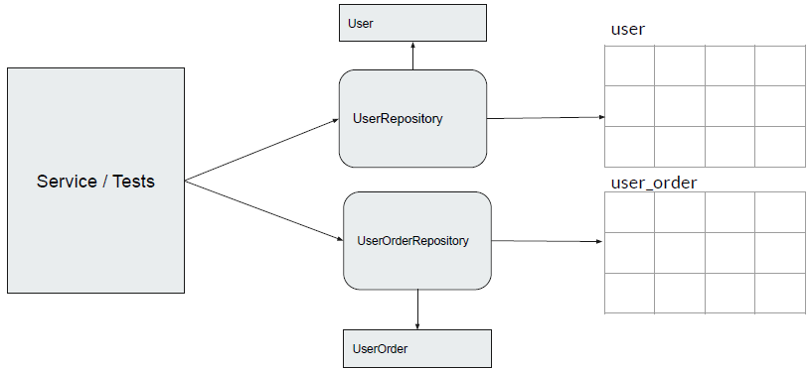

Spring automatically creates repositories class (UserRepository, UserOrderRepository) for us. So using the repository classes, we can select, for example, using the UserRepository, I can select all the users, insert new users, delete users, etc.

So our service classes/test classes, they will be using these repository classes to talk to the tables. Okay, so the UserRepository is responsible for dealing with the user entity.

The UserOrderRepository is responsible for dealing with the user order entity and those tables.

**Business Requirement**: Visa Application Process for Individual Travel

To facilitate the VISA application process for an individual’s travelling from X-Country to Y-Country.

Website: <https://vins-udemy.s3.amazonaws.com/sb/visa/udemy-visa.html>

Let’s start 🡪

Maven dependency & project setup with H2

* Create a directory under test/resources 🡪 table

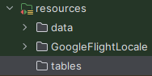

* Create a CSV file and paste it under table directory as mentioned above

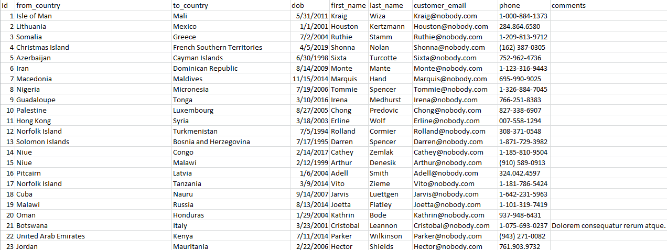

* Create a file with below data (kind of setup) 🡪 data.sql

DROP TABLE IF EXISTS customer;

CREATE TABLE customer AS SELECT * FROM CSVREAD('classpath:tables/user_visa.csv');

* Update pom.xml

<dependency>  
 <groupId>org.springframework.boot</groupId>  
 <artifactId>spring-boot-starter-data-jpa</artifactId>  
</dependency>  
<dependency>  
 <groupId>com.h2database</groupId>  
 <artifactId>h2</artifactId>  
 <scope>runtime</scope>  
</dependency>

**Spring Data JPA – Naming Conventions**

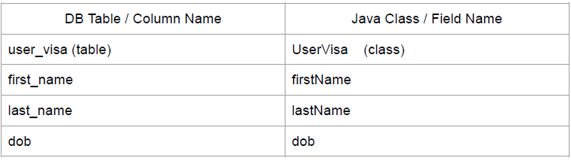

Mapping will happen automatically if we have such naming conventions in Spring Data JPA!!

Create Entity Classes 🡪 To indicate that a class represents an entity in a relational database.

Customer.java

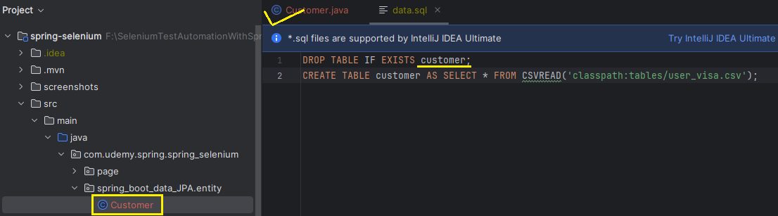

@Entity  
@Table(name = "customer")  
public class Customer {   
 @Id  
 private Integer id;  
 private String fromCountry;  
 private String toCountry;  
 private Date dob; // java.sql.Date  
 private String firstName;  
 private String lastName;  
 @Column(name = "customer_email")  
 private String email;  
 private String phone;  
 private String comments;  
  
 */**  
 * ----------------------------------Getter-Setters----------------------  
 */* public Integer getId() { return id; }  
 public void setId(Integer id) { this.id = id; }  
 public String getFromCountry() { return fromCountry; }  
 public void setFromCountry(String fromCountry) {  
 this.fromCountry = fromCountry;  
 }  
 public String getToCountry() { return toCountry; }  
 public void setToCountry(String toCountry) {  
 this.toCountry = toCountry;  
 }  
 public Date getDob() { return dob; }  
 public void setDob(Date dob) { this.dob = dob; }  
 public String getFirstName() { return firstName; }  
 public void setFirstName(String firstName) {this.firstName = firstName;}  
 public String getLastName() { return lastName; }  
 public void setLastName(String lastName) { this.lastName = lastName;}  
 public String getEmail() { return email; }  
 public void setEmail(String email) { this.email = email; }  
 public String getPhone() { return phone; }  
 public void setPhone(String phone) { this.phone = phone; }  
 public String getComments() { return comments; }  
 public void setComments(String comments) { this.comments = comments; }  
  
 */**  
 * ----------------------------------------------------------------------  
 */*}

Create Repository Interface 🡪

@Repository annotation in Spring is used to indicate that a class serves as a repository. It signifies that the decorated class provides mechanisms for storage, retrieval, update, deletion, and search operations on objects.

JpaRepository is part of Spring Data JPA and provides common database operations. By using @Repository, Spring will automatically detect and manage instances of CustomerRepository.

@Repository  
public interface CustomerRepository extends JpaRepository<Customer,Integer> {}

**Data-Driven Testing -- Query JPA Methods**

Page Object Creation for VISA Registration Page 🡪 VisaRegistrationPage.java

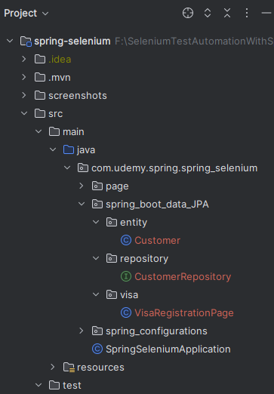

@PageAnnotations  
public class VisaRegistrationPage extends Base {  
 @Value("${visa.url}")  
 private URL url;  
  
 @Autowired  
 private LoggingService logger;   
 @FindBy(id = "first_4")  
 private WebElement firstName;  
  
 @FindBy(id = "last_4")  
 private WebElement lastName;  
  
 @FindBy(id = "input_46")  
 private WebElement fromCountry;  
  
 @FindBy(id = "input_47")  
 private WebElement toCountry;  
  
 @FindBy(id = "input_24_month")  
 private WebElement month;  
  
 @FindBy(id = "input_24_day")  
 private WebElement day;  
  
 @FindBy(id = "input_24_year")  
 private WebElement year;  
  
 @FindBy(id = "input_6")  
 private WebElement email;  
  
 @FindBy(id = "input_27_phone")  
 private WebElement phone;  
  
 @FindBy(id = "input_45")  
 private WebElement comments;  
  
 @FindBy(id = "submitBtn")  
 private WebElement submit;  
  
 @FindBy(id = "requestnumber")  
 private WebElement requestNumber;  
  
 @Override  
 public boolean isAt() {  
 return false;  
 }

public void goTo() {  
 this.driver.get(this.url.toString());  
 }

public void setNames(String firstName, String lastName) {  
 this.logger.logMessage("Getting names : " + firstName);  
 this.firstName.sendKeys(firstName);  
 this.lastName.sendKeys(lastName);  
 }  
 public void setCountryFromAndTo(String countryFrom, String countryTo) {  
 new Select(this.fromCountry).selectByValue(countryFrom);  
 new Select(this.toCountry).selectByValue(countryTo);  
 }  
  
 public void setBirthDate(LocalDate localDate) {  
 new Select(this.year).selectByVisibleText(String.*valueOf*(localDate.getYear()));  
 new Select(this.day).selectByVisibleText(String.*valueOf*(localDate.getDayOfMonth()));  
 new Select(this.month).selectByValue(localDate.getMonth().toString());  
 }  
  
 public void setContactDetails(String email, String phone) {  
 this.email.sendKeys(email);  
 this.phone.sendKeys(phone);  
 }  
  
 public void setComments(String comments) {  
 this.comments.sendKeys(Objects.*toString*(comments, ""));  
 }  
  
 public void submit() {  
 this.submit.click();  
 }  
  
 public String getConfirmationNumber() {  
 this.webDriverWait.until((d) -> this.requestNumber.isDisplayed());  
 return this.requestNumber.getText();  
 }  
}

Create Test Class 🡪 CustomerVisaTest.java

public class CustomerVisaTest extends SpringBaseTestNGTests {  
 @Autowired  
 private CustomerRepository repository;  
  
 @Test  
 public void visaTest() {  
 // Print number of records in user_visa.csv  
 System.*out*.println("# Records: " + this.repository.findAll().size());  
 // Print the record of Id = 55  
 this.repository.findById(55).ifPresent(u -> System.*out*.println("Record[55]: " + u.getFirstName() + " " + u.getLastName()));  
 // Print the record of Id = 159. This won't print anything as this record doesn't exist in user_visa.csv  
 this.repository.findById(159).ifPresent(u -> System.*out*.println("Record[159]: " + u.getFirstName() + " " + u.getLastName()));  
 }  
}

Run CustomerVisaTest

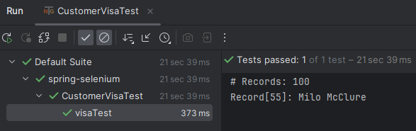

public class CustomerVisaTest extends SpringBaseTestNGTests {  
 private static final Logger *logger* = LoggerFactory.*getLogger*(CustomerVisaTest.class);  
 @Autowired  
 private CustomerRepository repository;  
 @Autowired  
 private VisaRegistrationPage registrationPage;  
  
 @Test  
 public void visaTest1() {  
 // Print number of records in user_visa.csv  
 System.*out*.println("# Records: " + this.repository.findAll().size());  
 // Print the record of Id = 55  
 this.repository.findById(55).ifPresent(u -> System.*out*.println("Record[55]: " + u.getFirstName() + " " + u.getLastName()));  
 // Print the record of Id = 159. This won't print anything as this record doesn't exist in user_visa.csv  
 this.repository.findById(159).ifPresent(u -> System.*out*.println("Record[159]: " + u.getFirstName() + " " + u.getLastName()));  
 }  
  
 */**  
 * Submit VISA for 3 customers  
 */* @Test  
 public void visaTest3() {  
 List<Customer> customers = this.repository.findAll() // This method retrieves all records from the repository  
 .stream() // This converts the collection of records into a stream. Streams allow you to process elements sequentially or in parallel.  
 .limit(3) // This limits the stream to the first three elements. In other words, it selects only the first three records from the stream.  
 .collect(Collectors.*toList*()); // This collects the limited stream back into a list. The resulting list will contain at most three records.  
  
 for (Customer u : customers) {  
 *logger*.info("Inserting record of #"+u.getId());  
 this.registrationPage.goTo();  
 this.registrationPage.setNames(u.getFirstName(), u.getLastName());  
 this.registrationPage.setCountryFromAndTo(u.getFromCountry(), u.getToCountry());  
 this.registrationPage.setBirthDate(u.getDob().toLocalDate());  
 this.registrationPage.setContactDetails(u.getEmail(), u.getPhone());  
 this.registrationPage.setComments(u.getComments());  
 this.registrationPage.submit();  
  
 *logger*.info("Request confirmation # INFO : " + this.registrationPage.getConfirmationNumber());  
 *logger*.warn("Request confirmation # WARN : " + this.registrationPage.getConfirmationNumber()); }}}

Run CustomerVisaTest

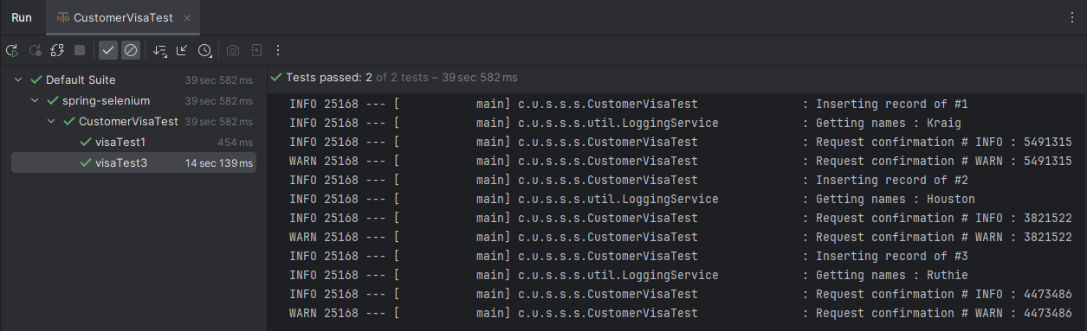

[Repository Query Keywords](https://docs.spring.io/spring-data/jpa/reference/repositories/query-keywords-reference.html)

[JPA Query Methods](https://docs.spring.io/spring-data/jpa/reference/jpa/query-methods.html) 🡪 Describes the various ways to create a query with Spring Data JPA. The JPA module supports defining a query manually as a String or having it being derived from the method name.

Derived queries with the predicates IsStartingWith, StartingWith, StartsWith, IsEndingWith, EndingWith, EndsWith, IsNotContaining, NotContaining, NotContains, IsContaining, Containing, Contains the respective arguments for these queries will get sanitized. This means if the arguments actually contain characters recognized by LIKE as wildcards these will get escaped so they match only as literals. The escape character used can be configured by setting the escapeCharacter of the @EnableJpaRepositories annotation.

Let’s use them

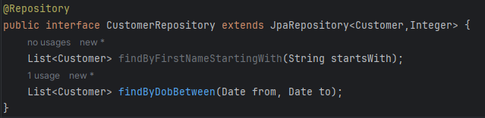

**Parameterize Data Provider**

<!DOCTYPE suite SYSTEM "http://testng.org/testng-1.0.dtd" >  
<suite name="spring-boot" parallel="tests" thread-count="3">  
 <test name="VTest_1">  
 <parameter name="dobStartFrom" value="1995-01-01"/>  
 <parameter name="dobEndTo" value="1997-01-01"/>  
 <classes>  
 <class name="com.udemy.spring.spring_selenium.spring_boot_data_JPA.CustomerVisaTest" />  
 </classes>  
 </test>  
</suite>



@DataProvider  
@Test(dataProvider = "getData")  
public void visaTest3(Customer u) {  
 this.registrationPage.goTo();  
 this.registrationPage.setNames(u.getFirstName(), u.getLastName());  
 this.registrationPage.setCountryFromAndTo(u.getFromCountry(), u.getToCountry());  
 this.registrationPage.setBirthDate(u.getDob().toLocalDate());  
 this.registrationPage.setContactDetails(u.getEmail(), u.getPhone());  
 this.registrationPage.setComments(u.getComments());  
 this.registrationPage.submit();  
  
 *logger*.info("Request confirmation # INFO : " + this.registrationPage.getConfirmationNumber());  
 *logger*.warn("Request confirmation # WARN : " + this.registrationPage.getConfirmationNumber());  
  
}  
  
@DataProvider  
public Object[][] getData(ITestContext context) {  
 return this.repository.findByDobBetween(  
Date.*valueOf*(context.getCurrentXmlTest().getParameter("dobStartFrom")),  
Date.*valueOf*(context.getCurrentXmlTest().getParameter("dobEndTo"))  
 )  
 .stream().limit(3).map(o -> new Customer[]{o}) .toArray(Object[][]::new);  
}

**Spring Data JPA – Summary**

* JPA - Java Persistence API
* Provides a nice abstraction to connect to various SQL/NoSQL Databases
* CRUD w/o any SQL
* Data driven tests
* To treat CSV like a table.

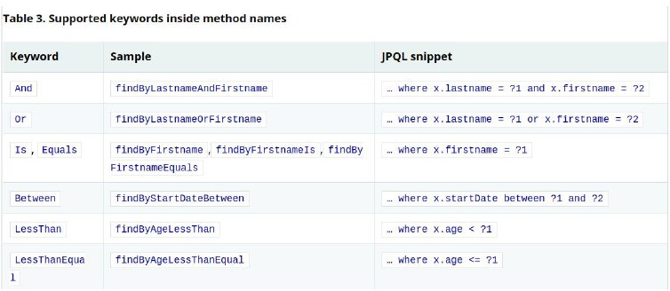

By default, Spring Boot configures the application to connect to an in-memory H2 database with the username sa and an empty password.

application.properties

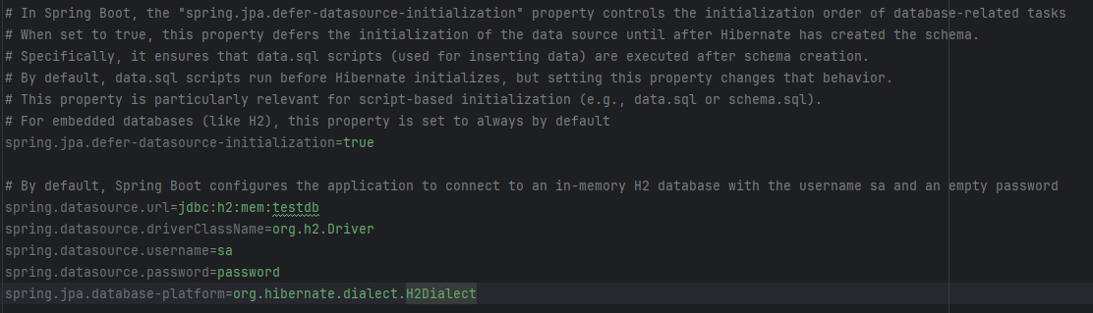

data.sql

DROP TABLE IF EXISTS customer;  
CREATE TABLE customer AS SELECT * FROM CSVREAD('classpath:tables/user_visa.csv');  
INSERT INTO Customer (id, from_country, to_country, dob, first_name, last_name, customer_email, phone, comments) VALUES (101, 'Iron', 'Man', '2011-05-31', 'Tony', 'Stark', 'tony@stark.com', '1-000-882-1575', NULL);  
INSERT INTO Customer (id, from_country, to_country, dob, first_name, last_name, customer_email, phone, comments) VALUES (102, 'Captain', 'America', '2011-05-31', 'Steve', 'Roger', 'steve@roger.com', '1-000-884-1545', NULL);  
INSERT INTO Customer (id, from_country, to_country, dob, first_name, last_name, customer_email, phone, comments) VALUES (103, 'Banner', 'Dunker', '2011-05-31', 'Banner', 'Dunker', 'banner@dunker.com', '1-000-887-1544', NULL);

CustomerVisaTest

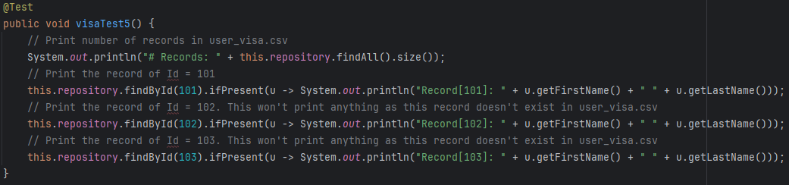

Run the test

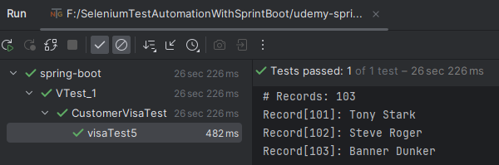

**Spring Data JPA - H2**

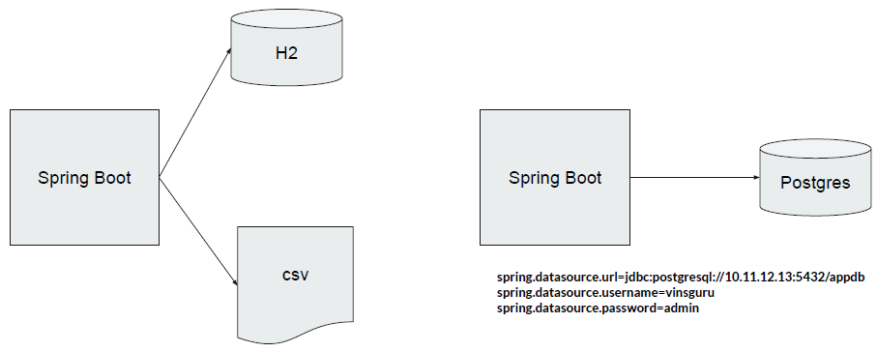

We read the data from CSV, load it to in-memory DB H2

